PSHE - Citizenship

We will learn about:

* Democracy and the local council
* Diverse communities
* Rights of the child
* Charity

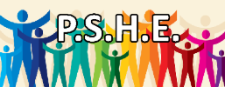

PE

Orienteering and field work

Athletics with games and sports day practice.



RE - When Jesus left; what was the impact of Pentecost?

We will be learning about:

* The events of Pentecost.
* The main events of the story in the Bible.

DT Structures – Castles

We will be looking at features of a castle then designing and constructing a castle made up of 3d shapes and nets.

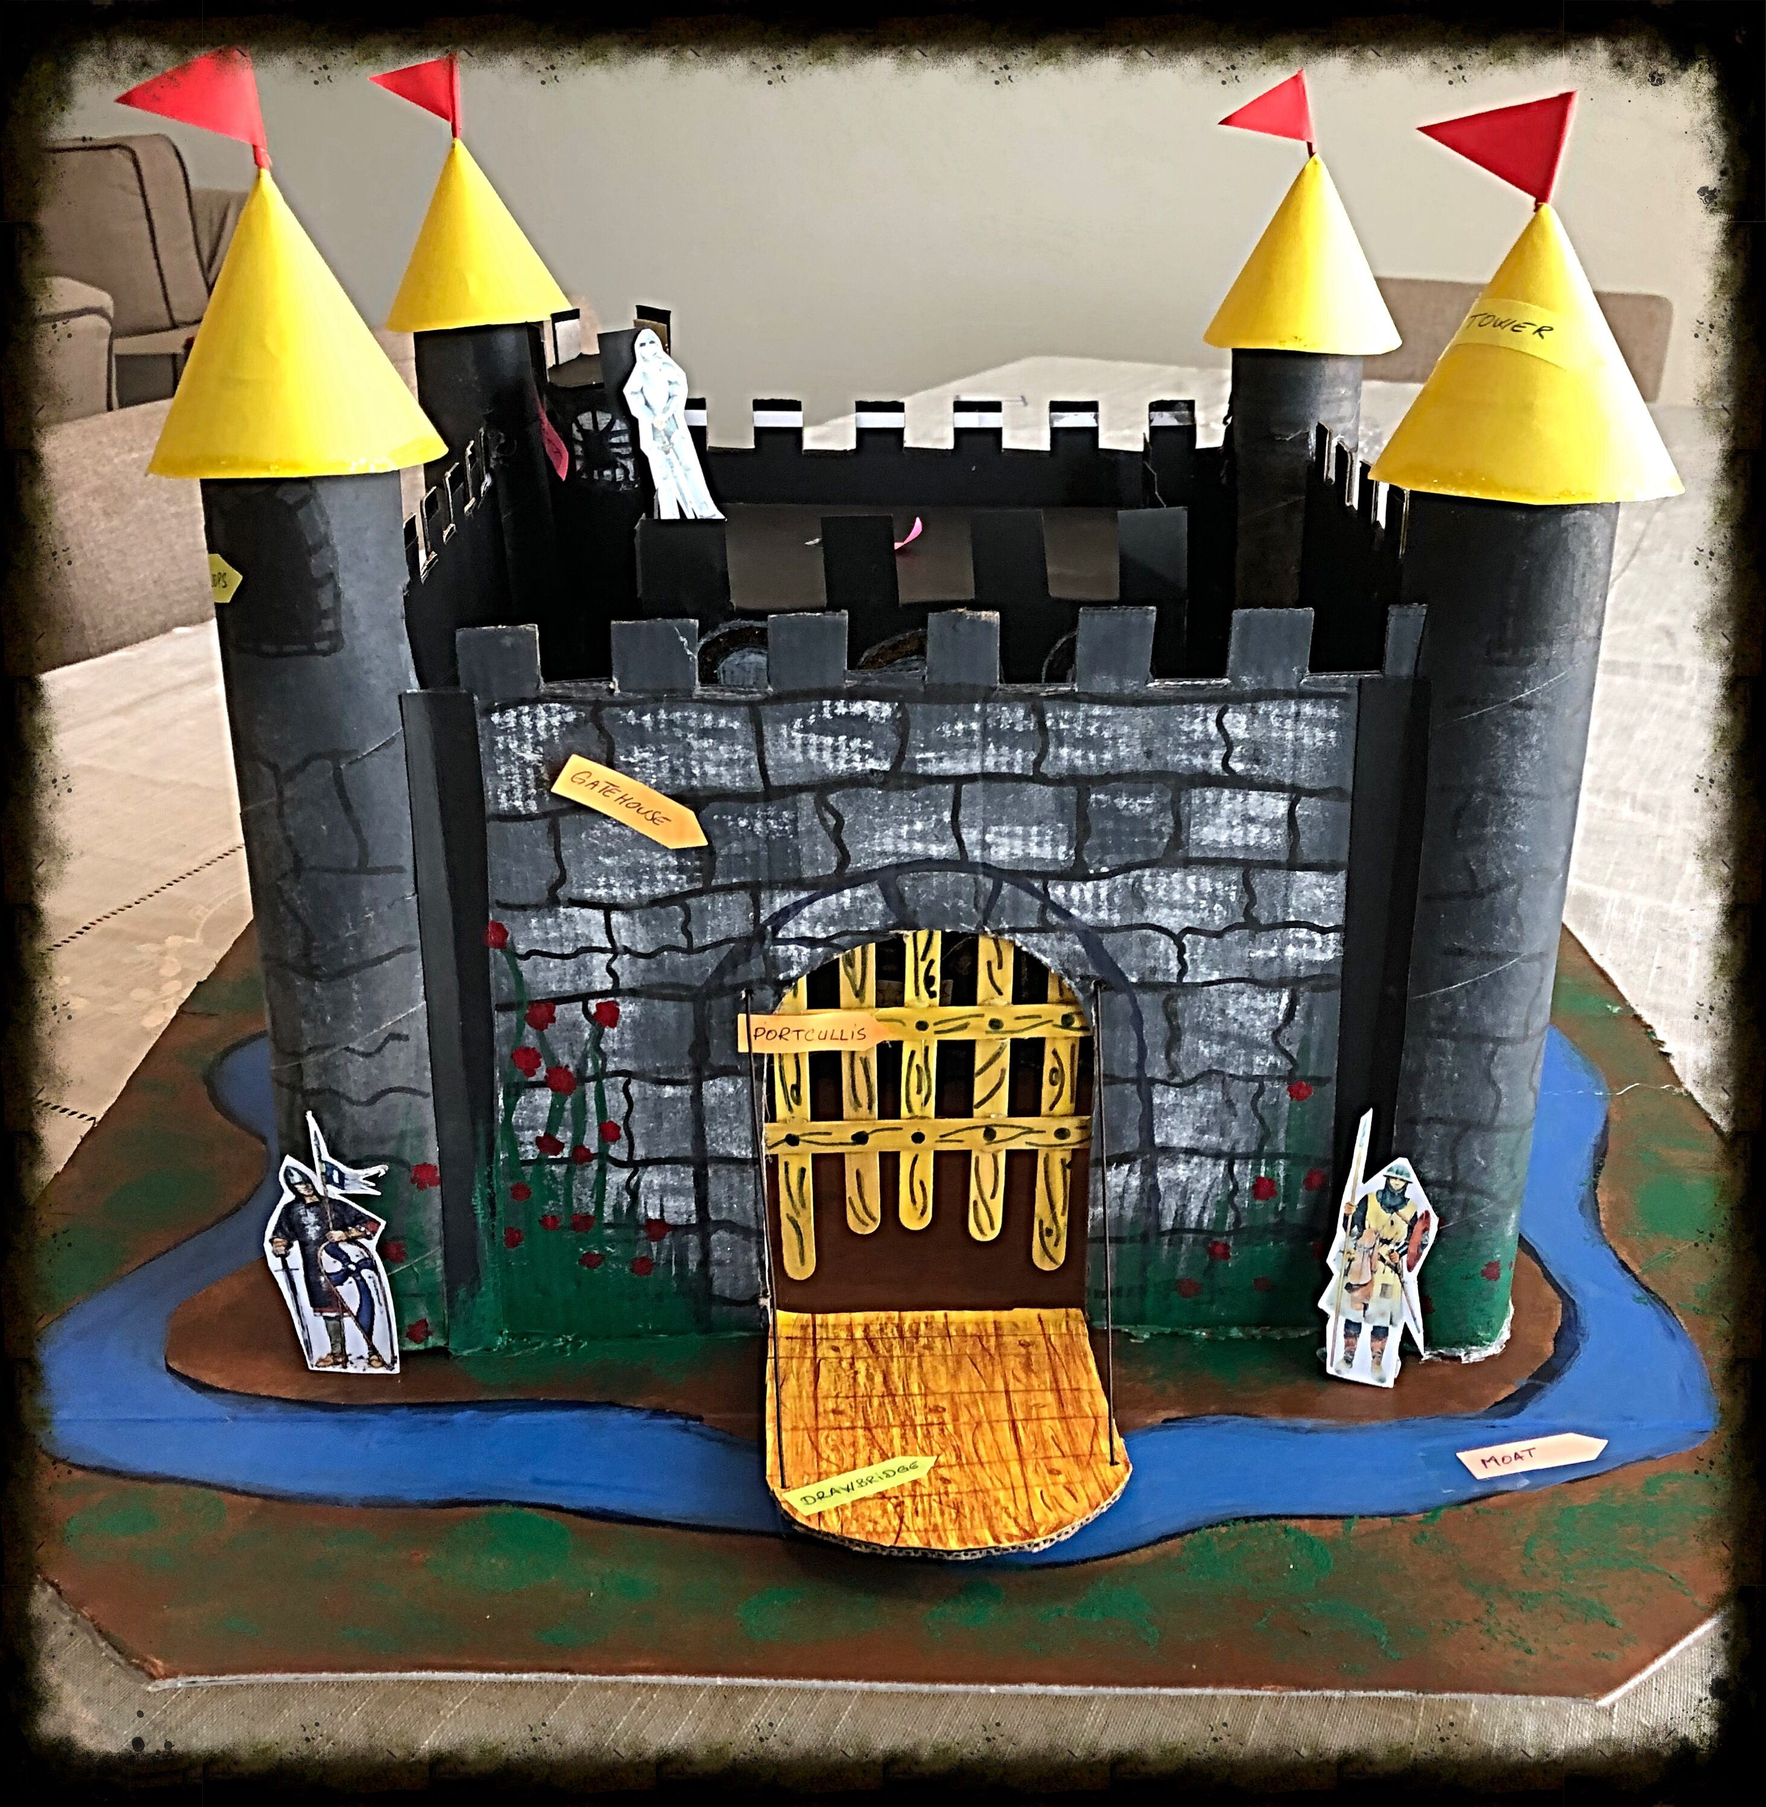

Music – Samba and Carnival

We will be learning:

* The history and culture behind Samba drumming.
* How to compose rhythms
* To keep the pulse

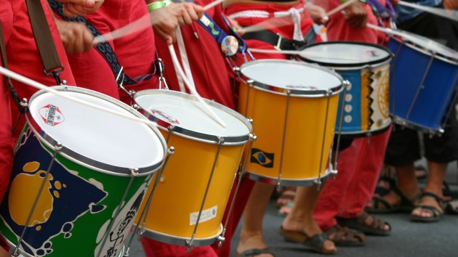

Computing – Word Processing

We will be learning to:

* Type and edit a document
* Insert an image
* Insert and complete tables
* Plan the layout of a document



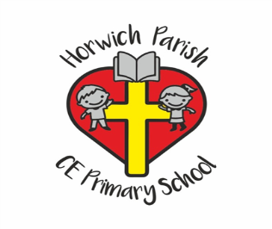

4B

Summer one

History – How hard was it to invade and settle in Britain?

We will be learning:

Who were the Anglo-Saxons and the Scots?

What did Anglo-Saxon settlements look like?

What does Sutton Hoo tell us about Anglo-Saxon life?

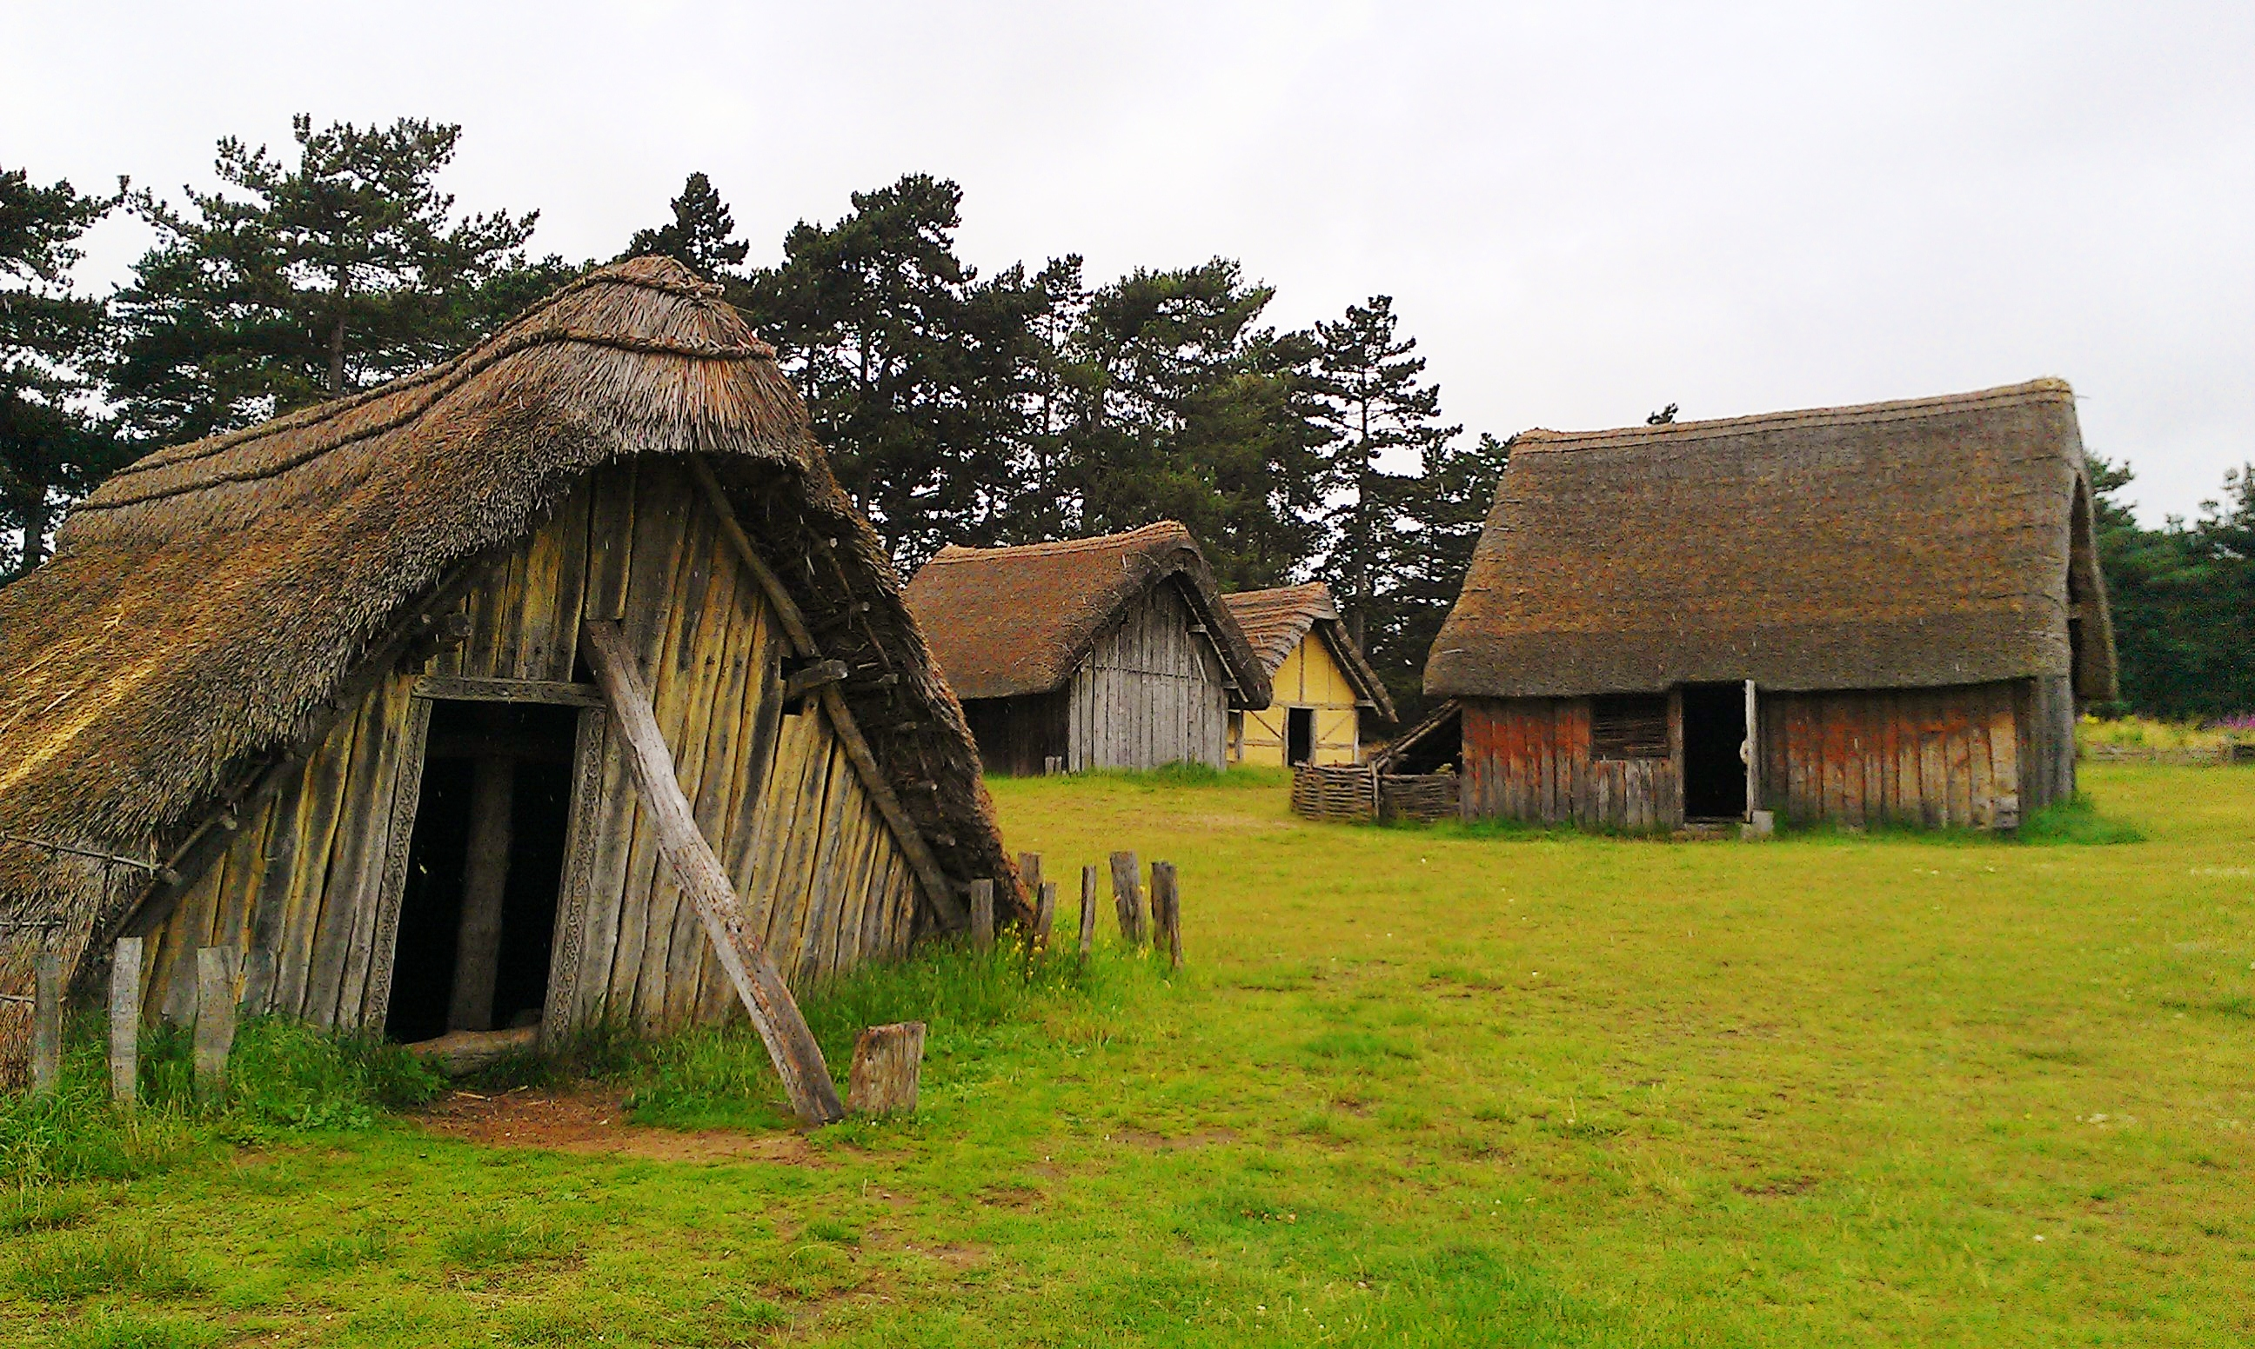

English

We will learn how to write a zoo information board for a rainforest exhibition.

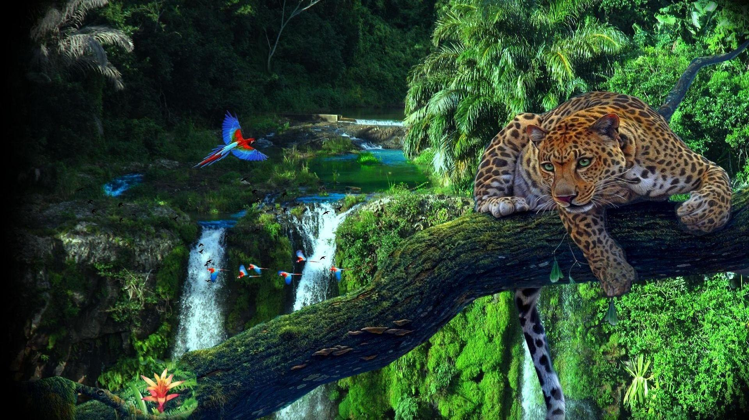

Maths – Decimals & Money

We will learn how to:

* Compare, order and round decimals
* Write money as decimals
* Solve money problems and calculations

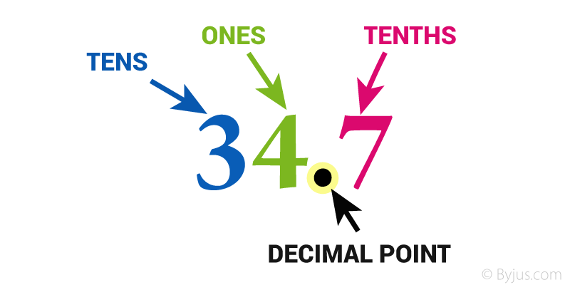

Science – Plant Reproduction

We will learn to:

Identify what plants need to grow healthily.

Describe the structure and function of the parts of flowering plants.

Investigate how plants transport water.

