RE

We will be focusing on gospel work with the key question: what good news did Jesus bring?  
We will be exploring the good deeds of Jesus and how people can use him as an example today.

PSHE

First, we will continue to learn about citizenship. Including: looking after others, belonging and how to make democratic decisions.

Then, we will move onto learning about economic wellbeing.

PE

We will be learning how to play tennis.

We will be building our wrist strength to keep a steady racquet hold.

We will be serving and returning balls.

Geography

We will be focusing on coastal areas of the UK.

We will be using atlases and Google Earth to explore distant places.

We will be learning about the importance of seas and oceans in maintaining a healthy planet.

English

Our focus text will be: Toys in Space by Mini Grey.

We will be exploring fantasy stories and expanding our vocabulary with imaginative adjectives.

We will continue to develop our fundamental writing skills (capital letters and full stops).

Maths

First, we will continue to focus on measurement and mass.

Then, we will move onto multiplication and division; focusing on counting in 2s, 5s and 10s.

Music

We will be learning about pitch and tempo through a Superhero theme.

We will continue to experiment with our bodies as instruments.

We will use percussion and keyboards.

DT

We will be working with textiles to make puppets.

We will be learning basic stitch patterns.

Computing

We will continue to use google docs to build our digital literacy skills – adding to and amending documents.

Science

We will be focusing on woodland, rainforest and ocean habitats.   
We will be exploring the 7 life processes.

We will learn about food chains and how they keep a balanced habitat.

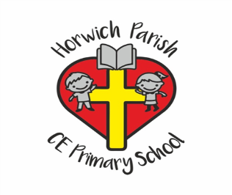

Year 1

Summer 1