PSHE

We will be continuing to learn how to keep ourselves safe at home, in school and the wider community.

We will be beginning to learn about citizenship and how rules help make a safe world for all.

Music

We will be learning how to change the dynamics of our voice to re-tell The Three Little Pigs.

DT

We will be following the plan, make and evaluate process to create our own healthy smoothies.

Computing

We will be continuing to build our keyboard navigation skills and apply them to logging on.

RE

We will be learning about the Easter story and why it is an important festival.

PE

We will be continuing to work on our fundamental skills and apply them to a group dance.

Science

We will be learning all about plants including: plant parts and their properties, what plants need to grow, the difference between wild and garden plants and how to spot deciduous and evergreen trees.

English

Our focus text is Beegu by Alexis Deacon.

We will be learning to use adjectives to make our writing more descriptive. We will also be focusing on using ‘and’ as a connecting word to link two ideas together.

Maths

We will be focusing on place value within 50.

We will also move onto measuring length and height with cubes and rulers.

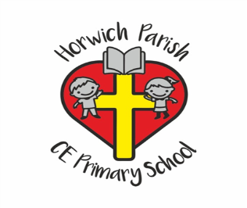

Year 1

Spring 2

History

We will be learning about how toys have changed and evolved over a period of 100 years.