aPppkhgdedsa

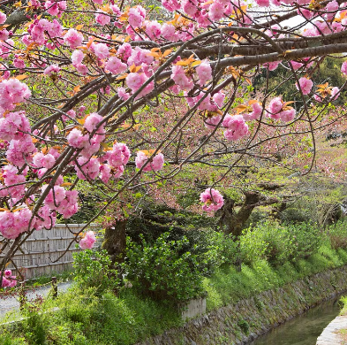

**PSHE**

**Citizenship**

* Recycling
* Reusing
* Local community groups

**Safety and the changing body**

* Choices and influences
* First Aid
* Road safety.

**Religious Education**

Salvation - Why do Christians call the day Jesus died Good Friday?

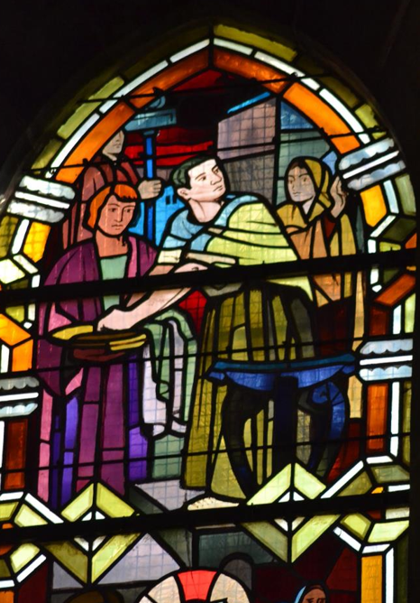

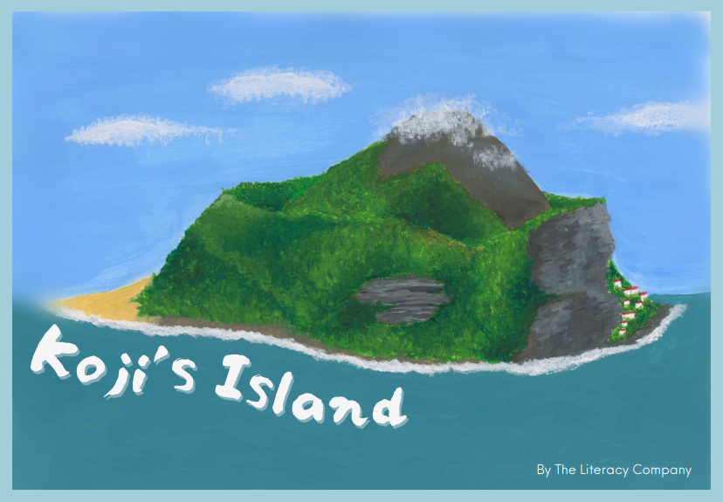

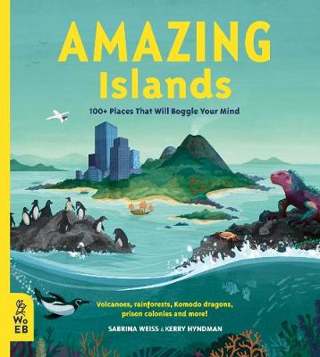

**Computer Science**

● Programming ● Sequencing ● Sound



**Geography**

**Are all settlements the same?**

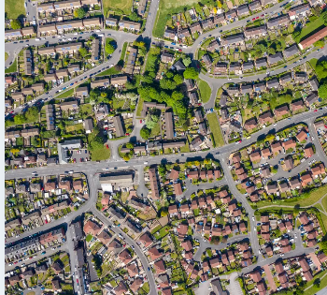

**Science**

Movement and Nutrition

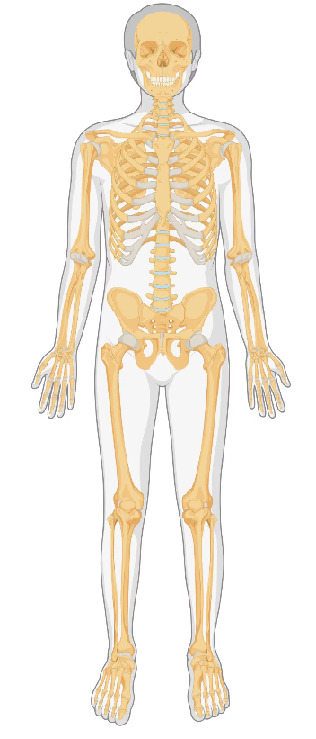

**Music- Haiku, Music & performance**

**Theme: Hanami festival**

**Art**

**Drawing – plants & botanicals**

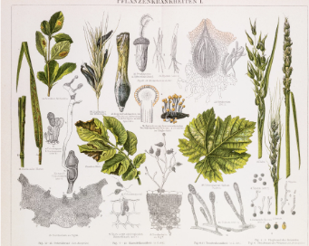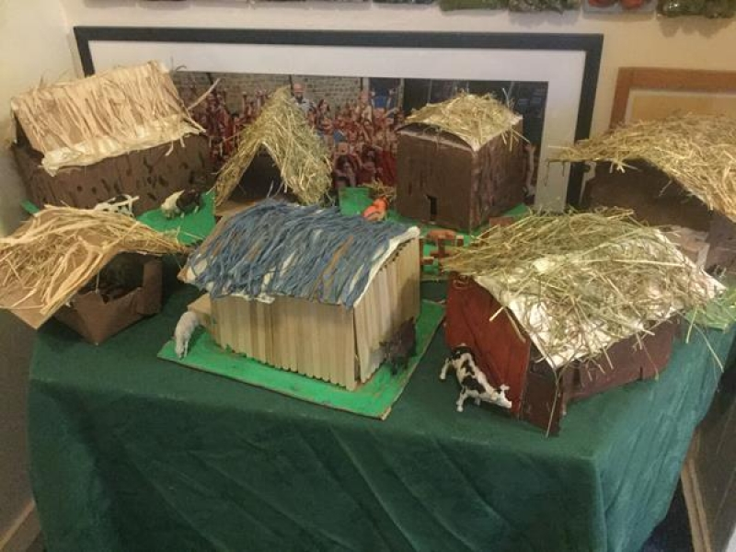

**P.E.**

**Key PE - Fencing**

**Striking and fielding**



**English**

**We will write a first person island adventure story.**

**Mathematics**

**Fractions**

**Decimals**

