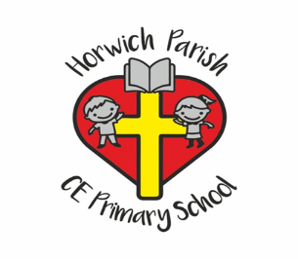
Relationships & Sex Education Questionnaire analysis
The survey was conducted in November 2020 and we received 40 returns.
82% of parents would like to be given information about RSE by email and 22.5 would like an afternoon or evening for parents. 45% of parents requested a list of resources to support learning at home.
School will offer an afternoon / evening each academic year for parents to attend. This session will be joined by either the school nurse of the healthy families team with parents given the opportunity to ask questions and seek advice.
- Are you aware of how Relationships education is currently taught at HP?
Yes = 17.5%
No 45%
Somewhat 37.5%
As a school to further inform parents regarding the contents of RSE a copy of the scheme of work we use is attached and is on our school website.
The healthy families team will visit school and deliver sessions as part of the RSE curriculum.
HHKids delivers sessions to the upper junior children (year 5 and year 6)

- Do you have any worries about Relationships and Sex education?
Great deal = 0%
Moderate 12.5%
Little 15%
None 72%
To support parents who are worried about RSE school will operate a system that allows parents to confidentially email school expressing their worries. A member of SLT will respond.
School will signpost parents to the school nurse if parents wish.

- Do you feel able to talk to your child regarding Relationship and sexual health?
Yes 65%
No 5%
Somewhat 25%
School will provide a list of resources for parents to use to support discussions and conversations at home.
Parents can be signposted to our school nurse for advice too.

- Are there any adaptions or changes that you think should be made to the new RSE policy?
Yes 2%
No 97.5%
The policy will be uploaded onto the school website.

