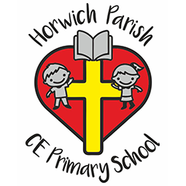
Resources
The children will use a wide range of tools and equipment to perform practical tasks.
The children will use a wide range of materials and components including construction materials, textiles, etc.

Curriculum Design & Organisation
Children will be taught Art which follows the Kapow scheme of work linked to the Early Years Foundation and National Curriculum objectives for Reception, Key Stage 1 and 2.
Horwich Parish curriculum focuses on the progression of skills throughout the children’s time at Horwich and vocabulary specific to Art.
Children are encouraged to become innovators and risk-takers.
We link work to other disciplines such as Maths, Science, Engineering, Computing and DT.

Teaching Approaches
We use a variety of teaching and learning styles in our Art lessons. We use whole-class teaching methods and combine these with enquiry-based research activities. Children are encouraged to ask as well as answer questions. Children have to opportunity to work practically and creatively to solve problems both as individuals and members of a team. Every classroom recognises the children’s achievements and celebrates them as unique individuals.

Art at
Horwich Parish CE school

Parental engagement

Newsletters will be used to celebrate any achievements.
We have open afternoons to celebrate the children’s work.
Art policy is available on the school website.
End of year reports will summarise individual children’s success in Art

