Ppppkhgdedsa

**English**



**Write a letter and a diary entry linked to refugees and evacuees**

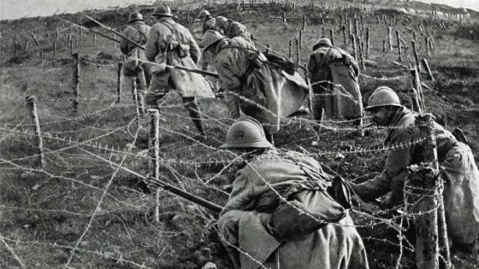

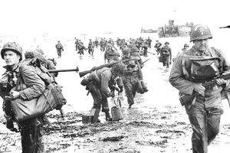

**Art**

**Drawing**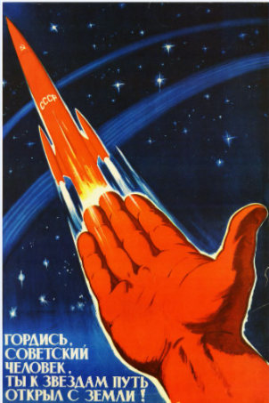

**Science**

**Evolution**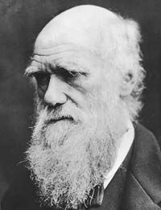

**Religious Education**

**What does it mean for Christians to believe that God is holy and loving?** 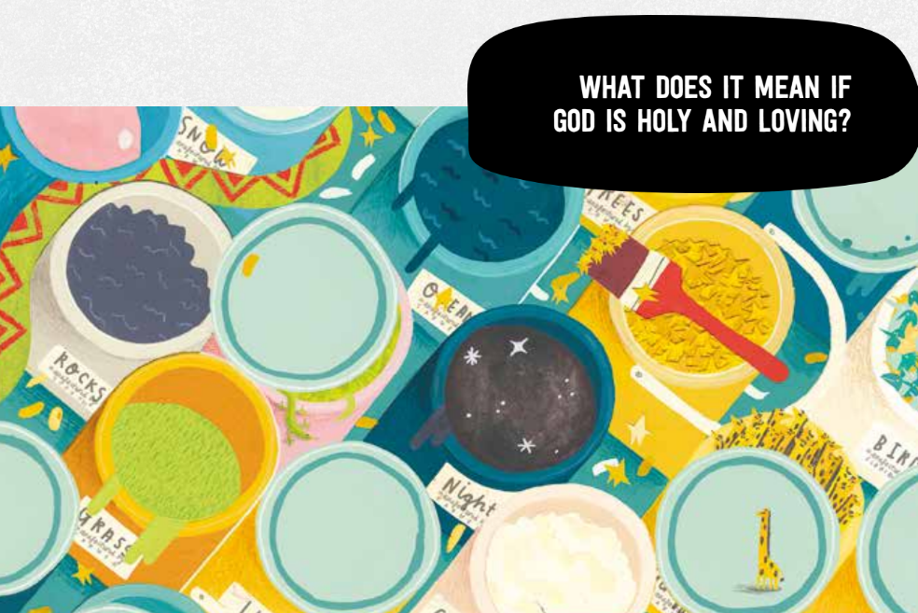

PSHE

Health and wellbeing – relaxation and sleep

**Computing Coding**



**P.E.**

**Attacking and defending**

History

Placing events in chronological order

Using primary and secondary sources

How did the war affect the people of Horwich?

**Maths**

**Ratio**

**Algebra**

