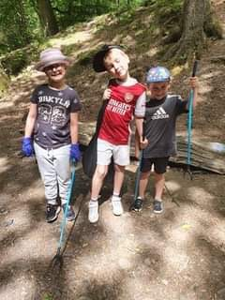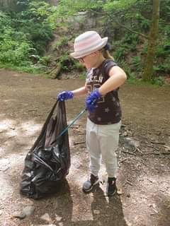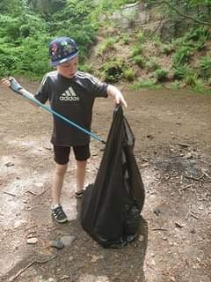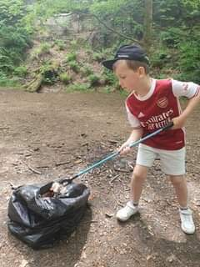

When Lewis, Naysa and Ethan found their favourite picnic spot covered in litter they decided to put their values into action. The following day they returned armed with litter pickers, bin bags and gloves and spent the day clearing up the local beauty spot for everyone to enjoy.

**Living Our Values**