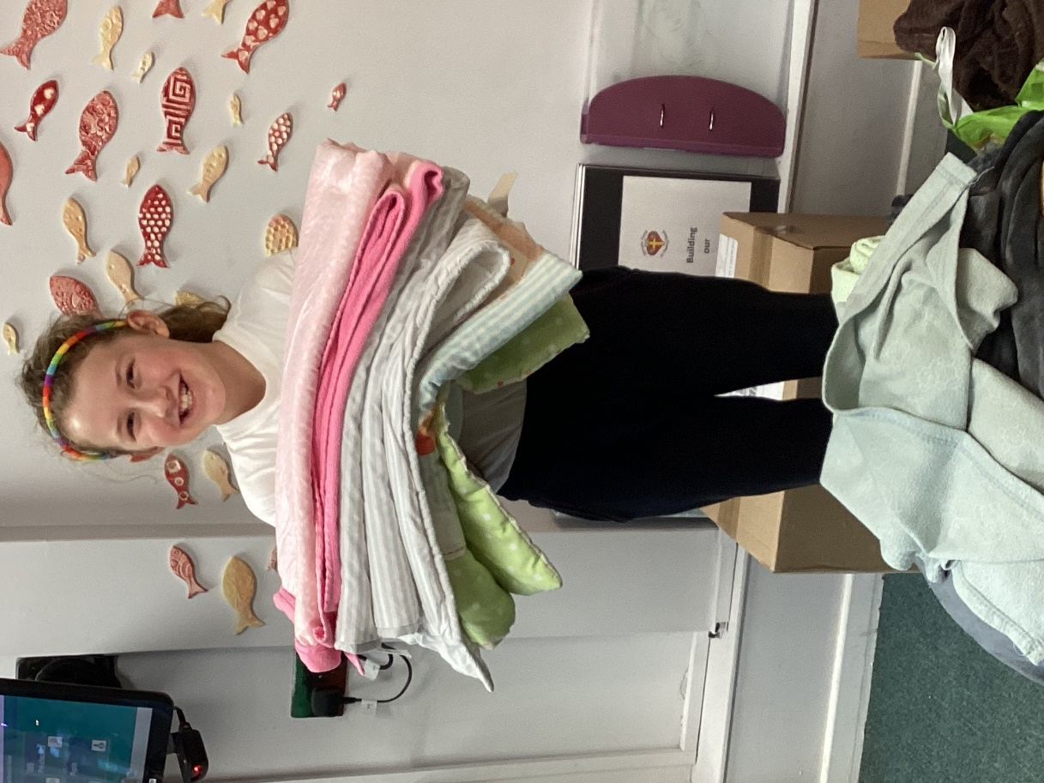

When Myla in Year 4 heard about the hardship that people were facing in Ukraine she sprang into action. She asked Mrs Mills how we could help as a school and together they came up with a plan. In exchange for donations of blankets to be sent to Ukraine we held a non-uniform day in school, the blankets were then sent to Ukraine via a collection that was being held at Mrs Mills church.

**Myla’s Ukraine Appeal**