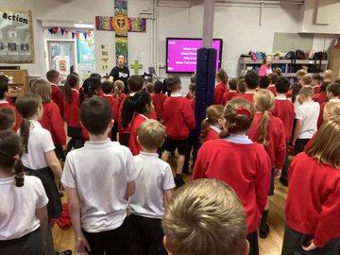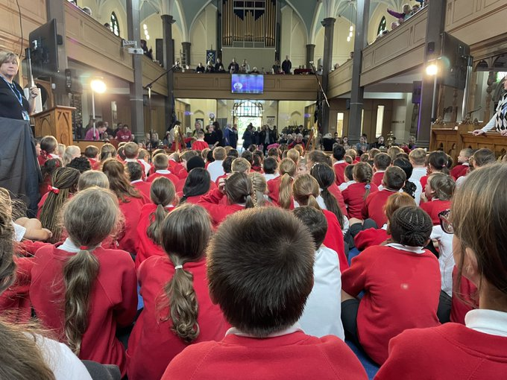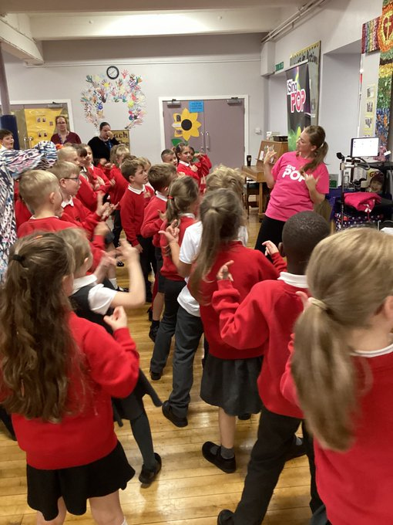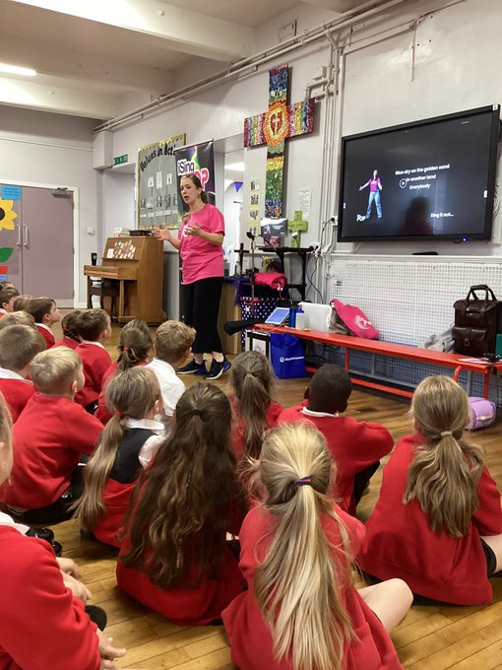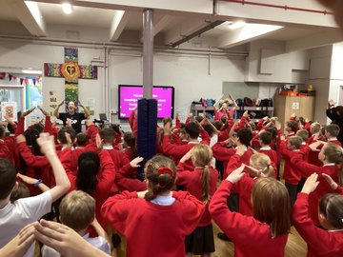

**In October the children loved the visit from the I SING POP team and getting to learn all the new songs and dances. The highlight was a concert at Holy Trinity Church where we all joined together to perform the songs for our friends and family.**

**I SING POP 2022**