Ppppkhgdedsa

**Religious Education**

Trust and Betrayal in the Easter Story

**P.E.**

**Striking and Fielding**

**Science**

**Sound**



**Music**

**4S Wider Opportunities Brass**

**4R Stop!**

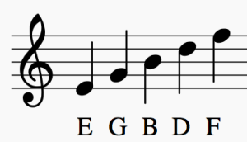

**DT**

**Textiles**



**English**

* **Narratives**
* **Poetry**

**PSHE**

* Computer Safety
* Diversity

**Computing**

* **Coding**
* **Computer Science**

**Maths**

* **Length & Perimeter**
* **Fractions**

