Ppppkhgdedsa

**Religious Education**

**Christmas – exploring the symbolism of Light**

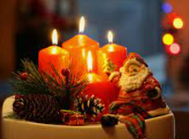

**P.E.**

**Gymnastics**

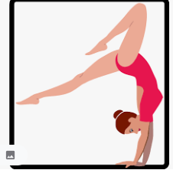

**Science**

**States of Matter**

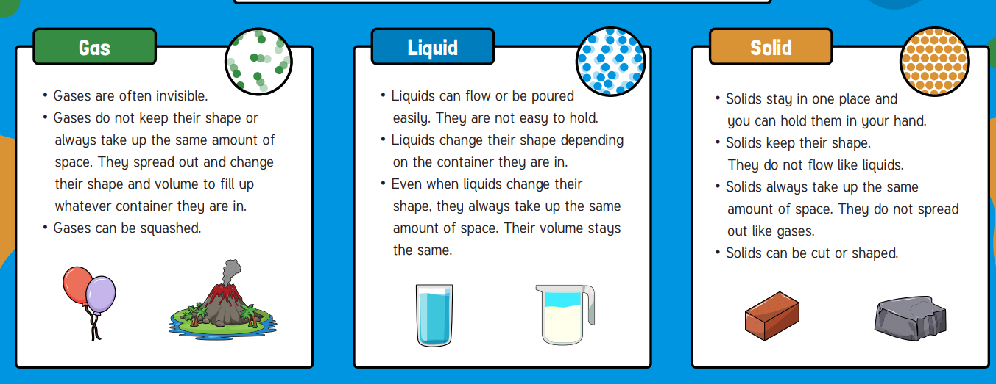

**Music**

**4R Wider Opportunities Brass**

**4B Glockenspiel Stage 2**

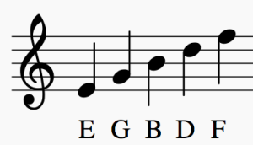

**DT**

**Stable**

**Structures**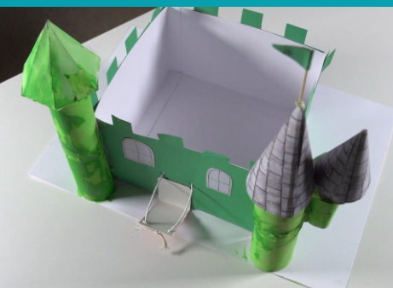

**English**

* **Narrative**
* **Instructions**
* **Poetry**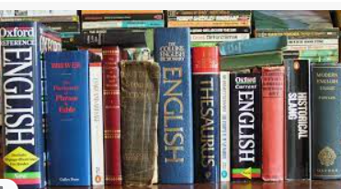

**PSHE**

* Being Responsible
* Diversity

**Computing**

* **Digital Literacy**
* **Basic Computer Skills**

**Maths**

* **Addition & Subtraction**
* **Area**
* **Multiplication & Division**
* **Times Tables**

