Evidencing the impact of Primary PE and Sports Premium at Horwich Parish CE School 2021 - 2022

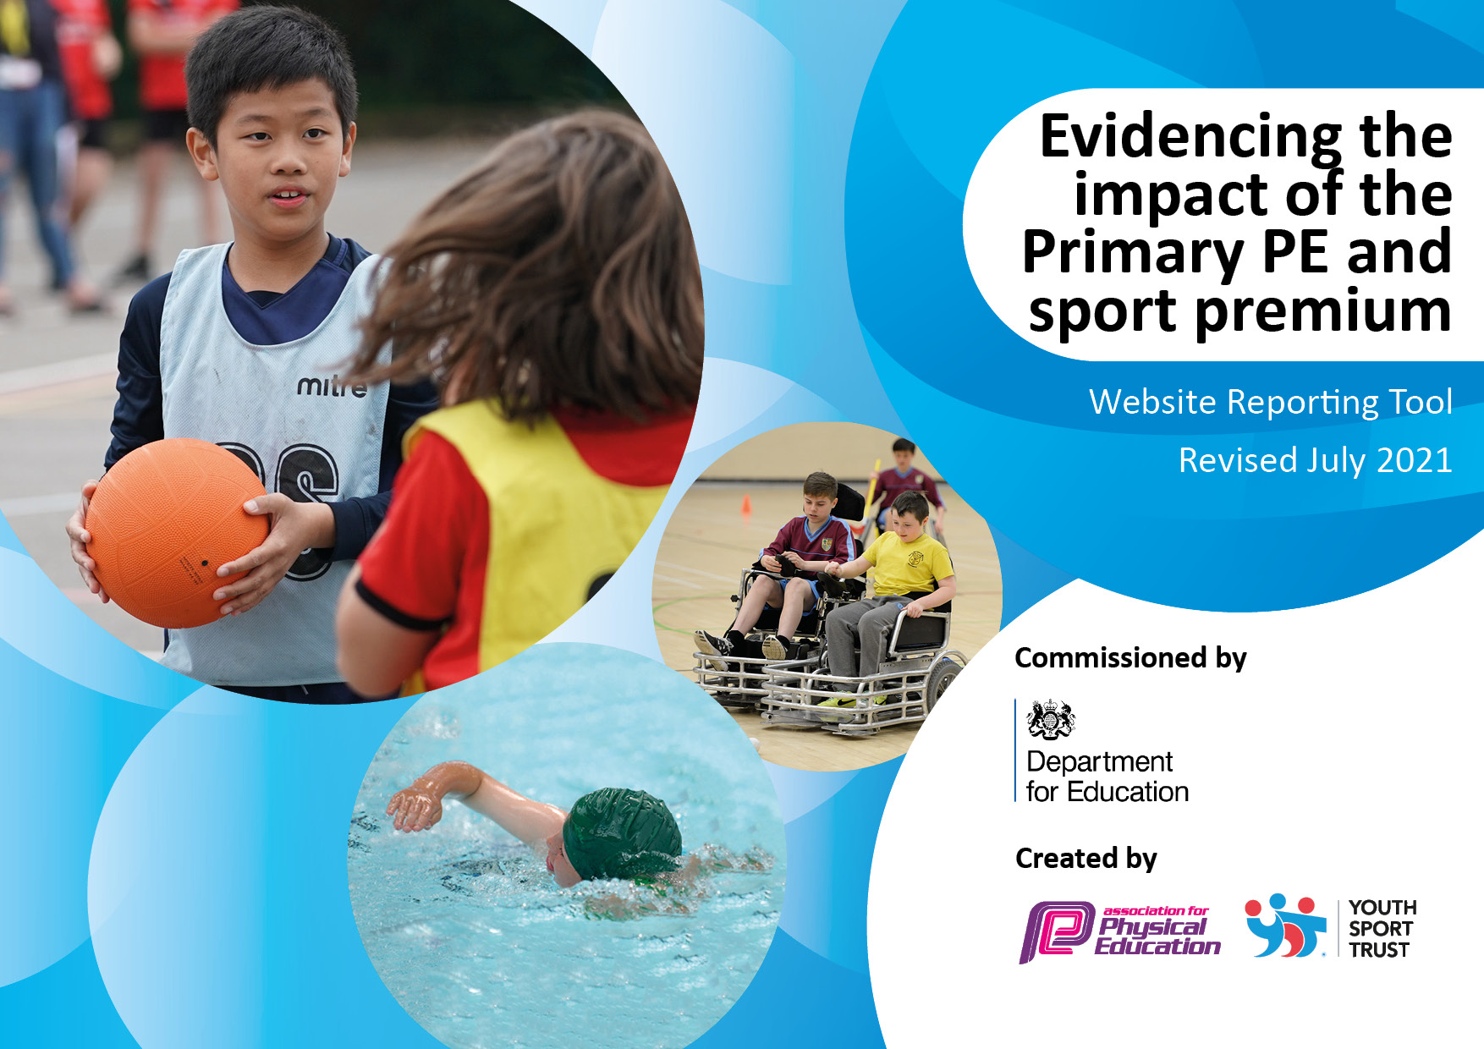
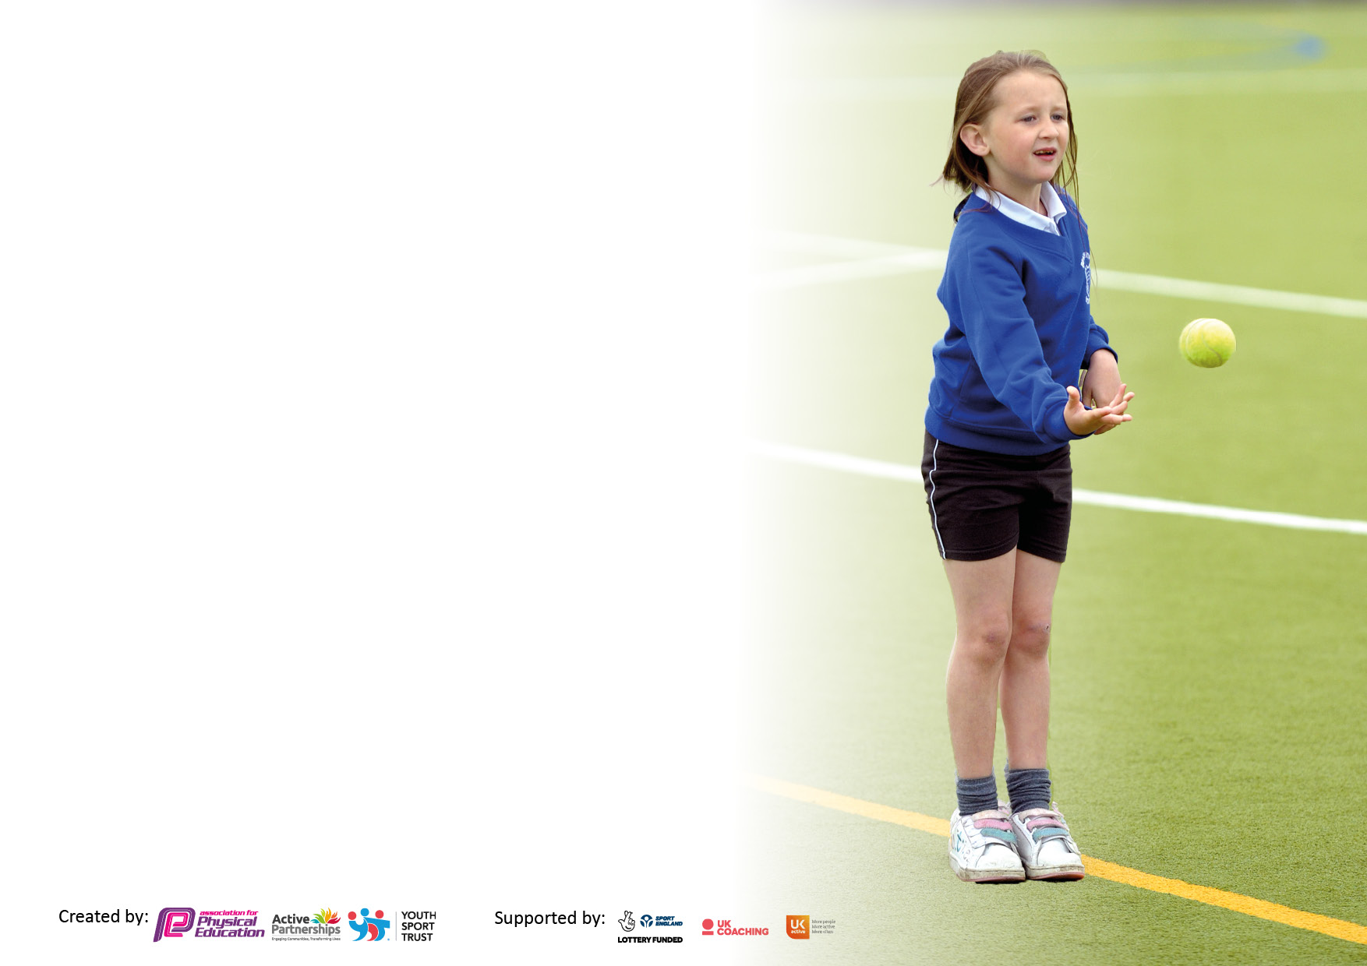

It is important that your grant is used effectively and based on school need. The Education Inspection Framework makes clear there will be a focus on ‘whether leaders and those responsible for governors all understand their respective roles and perform these in a way that enhances the effectiveness of the school’.

Under the Quality of Education Ofsted inspectors consider:
Intent - Curriculum design, coverage and appropriateness
Implementation - Curriculum delivery, Teaching (pedagogy) and Assessment
Impact - Attainment and progress

To assist schools with common transferable language this template has been developed to utilise the same three headings which should make your plans easily transferable between working documents.

Schools must use the funding to make additional and sustainable improvements to the quality of Physical Education, School Sport and Physical Activity (PESSPA) they offer. This means that you should use the Primary PE and sport premium to:

- Develop or add to the PESSPA activities that your school already offer
- Build capacity and capability within the school to ensure that improvements made now will benefit pupils joining the school in future years
- The Primary PE and sport premium should not be used to fund capital spend projects; the school’s budget should fund these.

Pleasevisitgov.ukfortherevisedDfEguidanceincludingthe5keyindicatorsacrosswhichschoolsshoulddemonstrate animprovement.Thisdocumentwillhelpyoutoreviewyourprovisionandtoreportyourspend.DfEencouragesschools to use this template as an effective way of meeting the reporting requirements of the Primary PE and sport premium.

We recommend you start by reflecting on the impact of current provision and reviewing the previous spend.

Schools are required to publish details of how they spend this funding, including any under-spend from 2019/2020, as well as on the impact it has on pupils’ PE and sport participation and attainment. All funding must be spent by 31st July 2022.

We recommend regularly updating the table and publishing it on your website throughout the year. This evidences your ongoing self-evaluation of how you are using the funding to secure maximum, sustainable impact. Final copy must be posted on your website by the end of the academic year and no later than the 31st July 2021. To see an example of how to complete the table please click HERE.
Created by: Supported by:

Details with regard to funding
Please complete the table below.

Total amount carried over from 2019/20 | £0
Total amount allocated for 2020/21 | £19,293
How much (if any) do you intend to carry over from this total fund into 2021/22? | £0
Total amount allocated for 2021/22 | £19,293
Total amount of funding for 2021/22. To be spent and reported on by 31st July 2022. | £19,293
Swimming Data
Please report on your Swimming Data below.

Meeting national curriculum requirements for swimming and water safety.

N.B. Complete this section to your best ability. For example you might have practised safe self-rescue techniques on dry land which you can then transfer to the pool when school swimming restarts.
Due to exceptional circumstances priority should be given to ensuring that pupils can perform safe self rescue even if they do not fully meet the first two requirements of the NC programme of study
What percentage of your current Year 6 cohort swim competently, confidently and proficiently over a distance of at least 25 metres?  N.B. Even though your pupils may swim in another year please report on their attainment on leaving primary school at the end of the summer term 2021.  Please see note above | 95%
What percentage of your current Year 6 cohort use a range of strokes effectively [for example, front crawl, backstroke and breaststroke]?  Please see note above | 90%
What percentage of your current Year 6 cohort perform safe self-rescue in different water-based situations? | 95%
Schools can choose to use the Primary PE and sport premium to provide additional provision for swimming but this must be for activity over and above the national curriculum requirements. Have you used it in this way? | No

Action Plan and Budget Tracking
Capture your intended annual spend against the 5 key indicators. Clarify the success criteria and evidence of impact that you intend to measure to evaluate for pupils today and for the future.

Academic Year: 2021/22 | Total fund allocated: £10,047 | Date Updated: 6/7/22
Key indicator 1: The engagement of all pupils in regular physical activity – Chief Medical Officers guidelines recommend that primary school pupils undertake at least 30 minutes of physical activity a day in school |  |  |  | Percentage of total allocation:
 |  |  |  | 52%
Intent | Implementation |  | Impact
Your school focus should be clear what you want the pupils to know and be able to do and about  what they need to learn and to  consolidate through practice: | Make sure your actions to achieve are linked to your intentions: | Funding allocated: | Evidence of impact: what do pupils now know and what can they now do? What has changed?: | Sustainability and suggested next steps:
All children at Horwich Parish should complete two weekly PE lessons which should consist of the teaching of specific skills and physical exercise.  Children should be encouraged to lead healthy and active lives.  Children should learn to be naturally active and seek own opportunities to exercise and live healthy lives. | Key PE coaches/ Coaches from Tom Luke Tennis/ School Teaching Staff ensure that children have complete two planned PE sessions per week throughout the academic year.  Children become inspired to actively engage in physical activity outside of PE lessons.  Teachers provide opportunity for children to complete active blasts during classroom activities (use of imoves) | Key PE SLA - £6,400  Tom Luke Tennis - £3,150  Imoves - £497 | Children are able to recall knowledge and skills taught during PE lessons.  Children can explain how they have maintained a minimum of 30 minutes of physical activity daily at school.  Children take part in physical activity through choice during break times. | Reintroduce daily mile as part of the school day.
Key indicator 2: The profile of PESSPA being raised across the school as a tool for whole school improvement |  |  |  | Percentage of total allocation:
 |  |  |  | 86%
Intent | Implementation |  | Impact
Your school focus should be clear what you want the pupils to know and be able to do and about  what they need to learn and to  consolidate through practice: | Make sure your actions to achieve are linked to your intentions: | Funding allocated: £16,635 | Evidence of impact: what do pupils now know and what can they now do? What has changed?: | Sustainability and suggested next steps:
The profile of sport and healthy/ active living should always be promoted as a priority within school.  Children should be encouraged to live active lives through regular exercise and a developed understanding of healthy living.  The quality of equipment used by the children during PE lessons should be of a suitable standard.  Children should be given the opportunity to engage in competitive sport through inter and intra sporting competition. | Skills taught through PE lessons – led by both teaching staff and Key PE sports provide all children at Horwich Parish with the skills to participate in and compete in sporting activities.  During PE lessons – all children are  PE at Horwich Parish should support the three pillars of progression (OFSTED PE Research Review 2022) Children physically progress, develop their awareness of terminology in sport and the rules to follow. This leads to the encouragement of children to take part in sport within the local and national community.  A significant proportion of children at Horwich Parish are invited to represent the school at inter-school competition. This was arranged in partnership with Sue Archibald (Autumn Term), Chorley Sports Partnership (Spring and Summer Term), Bolton School Sports (Full academic year).  All children at Horwich Parish take part in intra-competition meaning all children have the opportunity to take part in competitive sport. This took part during our annual Health Week where parents were invited to the whole school event. | As part of the £6,400 Key PE SLA  As part of the £3,150 Tom Luke Tennis SLA.  £150 – Sports Field Markings for Sports Day.  £1,350 – Chorley Sports Partnership SLA.  £600 – Susan Archibald SLA  Bolton Sports - £75  Sports Equipment - £4,910.35 | An increasing amount of children at Horwich Parish take part in sport outside of Horwich Parish.  Children are able to articulate the skills they have learnt and the sports these skills can be utilised in.  PE lessons are fully resourced with up to date sports equipment.  Horwich Parish has enjoyed a full year of inter and intra competitions both in the local cluster of schools and across Bolton.  Gold Award Achieved in the School Games Award. | Continue to develop the inclusion of both boys and girls in all sport.

Key indicator 3: Increased confidence, knowledge and skills of all staff in teaching PE and sport |  |  |  | Percentage of total allocation:
 |  |  |  | 50%
Intent | Implementation |  | Impact
Your school focus should be clear | Make sure your actions to | Funding | Evidence of impact: what do | Sustainability and suggested
what you want the pupils to know | achieve are linked to your | allocated: £9,550 | pupils now know and what | next steps:
and be able to do and about | intentions: |  | can they now do? What has
what they need to learn and to |  |  | changed?:
consolidate through practice:
For children to access a curriculum that ensures skills are developed progressively and that children understand the skills they develop combined with associated vocabulary.  Staff have the skillset enabling them to effectively deliver the PE curriculum. | Key PE sports SLA continued throughout the 21 – 22 academic year in order to allow teachers who required continued support developing their ability to teach PE observe coaches.  Tom Luke Tennis SLA provided CPD for staff in Foundation Stage and Key Stage 1 (two of the staff are new to Horwich Parish) in the coaching of Tennis and Cricket to younger children. | As part of the £6,400 SLA with Key PE Sports  As part of the £3,150 SLA with Tom Luke Tennis. | Children are able to specifically talk about the skills they have developed and can use associated vocabulary.  The quality of teaching in PE is of a good standard consistently delivered across school. | Staff to consolidate and practise the skills learnt through observing and team teaching with sports coaches.
Key indicator 4: Broader experience of a range of sports and activities offered to all pupils |  |  |  | Percentage of total allocation:
Intent | Implementation |  | Impact
Your school focus should be clear | Make sure your actions to | Funding | Evidence of impact: what do | Sustainability and suggested
what you want the pupils to know | achieve are linked to your | allocated:  £3,250 | pupils now know and what | next steps:
and be able to do and about | intentions: |  | can they now do? What has
what they need to learn and to |  |  | changed?:
consolidate through practice:
Additional achievements:  Children at Horwich Parish should have the opportunity to engage in the widest variety of sporting activities as possible to allow them to enjoy new sports and discover activities they would like to spend time developing further.  All children should be given the opportunity to realise their true potential in sport.  Children should be taught to understand the enjoyment to be had through taking part in sport and other physical activities as well as the benefits of living a healthy and active lifestyle. | The PE curriculum led by the staff at Horwich Parish, KE PE Sports and Tom Luke Tennis, ensure that children have learnt the skills necessary to succeed in the respective sports.  Event Days have been arranged to allow the children to experience a wider range of physical activity. | Bolton Sport Association - £75  Susan Archibald (Horwich and Blackrod Cluster Autumn Term) - £600  Chorley Sports Partnership - £1,350  Splats Entertainment - £720  Skipping Workshop - £325  Yoga After School Club - £180 | Children at Horwich Parish have all taken part in both competitive and non-competitive sporting activity.  They can talk about different experiences they have enjoyed throughout the year and explain how the events encourage physical activity.  The children continue to develop their skills in orienteering after the new scheme of work was introduced in 2021. | Develop opportunities for outdoor experiences for the children at Horwich Parish.

Key indicator 5: Increased participation in competitive sport |  |  |  | Percentage of total allocation:
 |  |  |  | 17%
Intent | Implementation |  | Impact
Your school focus should be clear | Make sure your actions to | Funding | Evidence of impact: what do | Sustainability and suggested
what you want the pupils to know | achieve are linked to your | allocated: | pupils now know and what | next steps:
and be able to do and about | intentions: |  | can they now do? What has
what they need to learn and to |  |  | changed?:
consolidate through practice:
All children should have to opportunity to participate in competitive sport. Inter-school and intra-school competitions should be planned throughout the year including the widest possible variety of sporting competitions. | Horwich Parish has then worked to ensure that as many different children have the opportunity to take part in inter-school and intra-school competitions.  These competitions have been designed to be either competitive or run as a festival allowing children of all abilities to realise their potential end enjoy the challenge and triumph of representing a school or team. | Bolton Sport Association - £75  Susan Archibald (Horwich and Blackrod Cluster Autumn Term) - £600  Chorley Sports Partnership - £1,350 | Horwich Parish Achieved ‘Gold’ in the School Games Award for participation in Inter-School Competitions and Festivals.  An increased amount of children took part in inter-school competition throughout the academic year.  Through pupil interviews, the amount of children taking part in sporting competition away from school is increasing. | Work to improve participation of girls in cricket and football at Inter-School Competition

Signed off by
Head Teacher: | Debbie Mills
Date: | 15-7-22
Subject Leader: | Stephen Banner
Date: | 6/7/22
Governor: | Susan M. Baines.
Date: | 16/07/22

