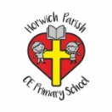 | RE Spring term 1 Year Six  Why is the Exodus such a significant event in Jewish and Christian history?
Key vocabulary | Explanation/ definition | Key Knowledge
Moses | The Hebrew prophet who led the Israelites out of Egypt and delivered the Law during their years of wandering in the wilderness. | - The Exodus is a significant event in Jewish and Christian history.  - The Seder is the special meal celebrated by Jews on the first evening of the festival of Passover.  - Christianity is rooted in Judaism and Jesus celebrated the Passover.  - For Jews, the event of the Exodus and Passover are at the very heart of their beliefs.  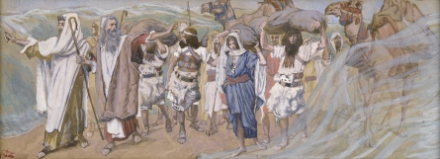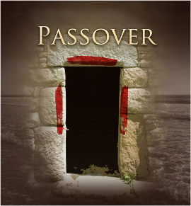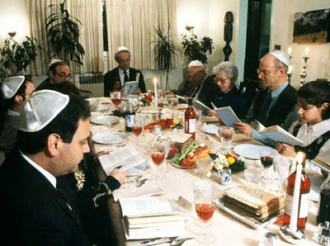  The Israelites Exodus from Egypt Special meal of Seder eaten on  the first evening of Passover
Exodus | The departure of the Israelites from Egypt.
Israel | A small country in the middle east and the place where two world religions, Judaism and Christianity began.
Freedom | - The state of being free or at liberty rather than in confinement or under physical restraint.  - Personal liberty, as opposed to bondage or slavery.  - Political or national independence.
Slavery | - The condition of a slave; bondage.  - The keeping of slaves as a practice or institution.
Slave | A person who is the property of and wholly subject to another; a bond servant.
Seder | A ceremonial dinner that commemorates the Exodus from Egypt and includes the reading of the Haggadah and the eating of symbolic foods.
Passover | A Jewish spring festival which celebrates the freedom of the Jews from slavery in ancient Egypt.
Key skills
By the end of this unit, pupils are expected to be able to:
- Retell in detail the story of the Exodus and connect it to the Passover celebration and Seder meal.
- Make links between the Passover, Last Supper and the Eucharist.
- Use appropriate religious vocabulary to show they understand why Passover is a festival of memory and freedom.
- Express their opinion about what freedom is and what is not.
- Identify the similarities and differences between the level of importance placed on the Exodus and Passover by Jews and Christians.
- Explain using appropriate religious language, the significance of the Passover and why it is not forgotten.

