RE Spring term 2 Year Six
Easter: Who was Jesus? Who is Jesus?
Key vocabulary | Explanation/ definition | Key Knowledge
Messiah | The promised deliverer of the Jewish nation prophesied in the Hebrew Bible.  Jesus is regarded by Christians as the Messiah of the Hebrew prophecies and the saviour humankind. | - Jesus is given a variety of names to describe his character and purpose.  - There is a strong connection between Christmas and Easter and the concepts of incarnation and salvation.  - Christian believe Jesus was/is the Messiah and what it means.  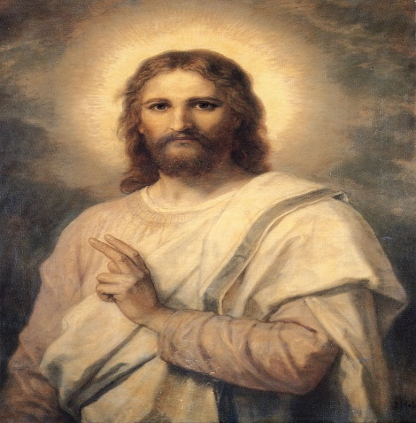  Jesus the Messiah/Prince of Peace Jesus’ Resurrection
Prince of Peace | A title given to Jesus Christ.
Saviour | - A person who saves someone from danger or difficulty.  - In Christianity God or Jesus Christ as the redeemer of sin and saver of souls.
Resurrection | - Rising again especially from the dead.  - The Resurrection: the coming back to life of Jesus Christ three days after he had been killed.
Redeemer | A person who redeems someone or something.
Redeem | - To buy or pay off.  - To reinstate oneself in someone’s good opinion.
Servant | - A person employed by another, to perform domestic duties or as a personal attendant.  - In the Bible it sometimes denotes a person who voluntarily dedicates themselves to the service of another.
Key skills
By the end of this unit, pupils are expected to be able to:
- Express their own and the opinion of others in response to the question ‘Who was Jesus’.
- Use appropriate religious vocabulary to show they understand Christian beliefs about Jesus.
- Ask relevant questions in order to discover the answer to the question ‘Who was Jesus’.
- Use the Bible as a source to discover the answer to the question ‘Who was Jesus’.

