RE Summer term 2 Year Six
Creation and Science, conflicting or complimentary?
Key vocabulary | Explanation/ definition | Key Knowledge
Genesis | the first book of the Bible, which describes how God made the world | Pupils will know that:  - There is much debate and some controversy around the relationship between the accounts in Genesis and contemporary scientific accounts.  - These debates and controversies relate to the purpose and interpretation of the texts. e.g. does reading Genesis as a poetic account conflict with scientific accounts?  - There are many scientists throughput history and now who are Christians.  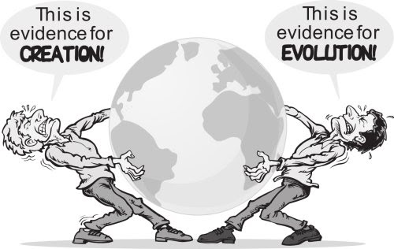  - The discoveries of science make Christians wonder even more about the power and majesty of the Creator.
cosmology | the study of the nature and origin of the universe
evolution | the way in which living things change and develop over millions of years
universe | everything that exists, esp. all physical matter, including all the stars and planets in space
contemporary | existing or happening now
complementary | different but useful or attractive when used together
conflict | if beliefs, needs, or facts, etc. conflict, they are very different and cannot easily exist together or both be true
science | the systematic study of the structure and behaviour of the natural and physical world, or knowledge obtained about the world by watching it carefully and experimenting.
Key skills
By the end of this unit, pupils are expected to be able to:
- Outline the importance of Creation on the timeline of the ‘Big Story’ of the Bible.
- Identify what type of text some Christians say Genesis 1 is, and its purpose.
- Taking account of the context, suggest what Genesis might mean, and compare ideas with ways in which Christians interpret it, showing awareness of different interpretations.
- Make clear connections between Genesis 1 and Christian belief about God as Creator.
- Show understanding of why many Christians find science and faith go together.
- Identify key ideas arising from their study of Genesis 1 and comment on how far these are helpful or inspiring, justifying their responses.
- Weigh up how far the Genesis 1 creation narrative is in conflict, or is complementary, with a scientific account.

