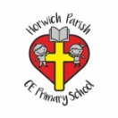 | RE Summer term 1 Year Five  Pentecost, what happened next?
Key vocabulary | Explanation/ definition | Key Knowledge
Pentecost | Pentecost is a Christian festival that takes place on the seventh Sunday after Easter and celebrates the sending of the Holy Spirit to the first followers of Jesus. | - the Book of Acts records the actions of what happened after Pentecost.  - the early Christians were persecuted for over 300 years and had to show great courage and perseverance.  - St Paul is a significant person in the history of Christianity and why.  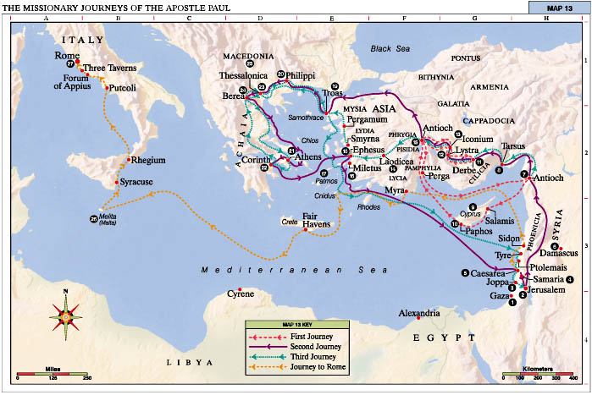  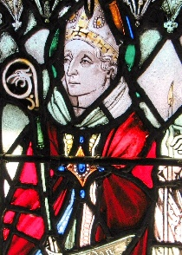  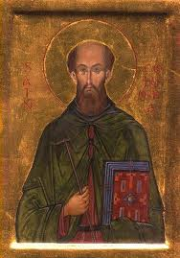  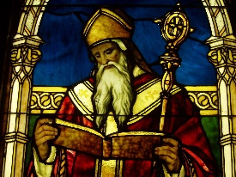  St. Columba St. Aidan St. Augustine
Saul | Saul changed his name to Paul. He was called to be an Apostle. He became a missionary for the Church. He wrote many letters. He went to many lands and taught the gospel.
gospel | the teachings of Jesus and the apostles
apostle | any of the early followers of Jesus who carried the Christian message into the world
New Testament | The New Testament is the part of the Bible that deals with the life and teachings of Jesus Christ and with Christianity in the early Church.
Letter | a written message from one person to another
Mission | a specific task or duty assigned to a person or group of people
Columba | Saint Columba ﻿ (7 December 521 – 9 June 597) was an Irish abbot and missionary credited with spreading Christianity in present-day Scotland
Aidan | In the seventh century, St. Aidan was the Bishop of Lindesfarne, an island in the North Sea, where he converted the Celts living in England’s far north.
Augustine | In the late 6th century, a man was sent from Rome to England to bring Christianity to the Anglo-Saxons. He would ultimately become the first Archbishop of Canterbury, establish one of medieval England’s most important abbeys, and kickstart the country’s conversion to Christianity.
Key skills
By the end of this unit, pupils are expected to be able to:
- retell the story of the conversion of St Paul.
- explain the impact of the conversion of St Paul then and now.
- talk about the content and impact of the teaching of St Paul.
- talk about what they have learnt and in what ways they have been inspired by their learning.
- interpret Paul’s teaching in 1 Corinthians 13 for people in today’s society.

