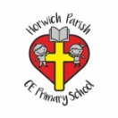 | RE Autumn term 1 Year Five  How and why do Christians read the Bible?
Key vocabulary | Explanation/ definition | Key Knowledge
Old Testament | The first part of the Christian Bible, written before the birth of Jesus Christ. | - There are several different genres of writing in the Bible.  - There are many translations of the Bible in English and other languages.  - The Bible is used to help answer questions about creation, truth, suffering and death, values for life and ethical issues.  - People of other faiths have holy books that teach, guide and impact on their daily lives.  - The Bible is the inspired word of God.  - The Bible gives guidance for Christian living and this impacts on believers lives and communities.  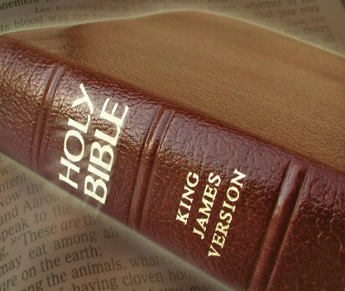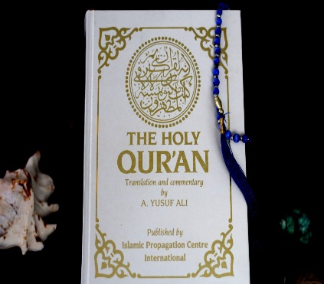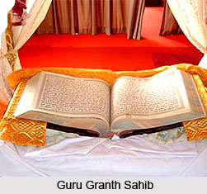  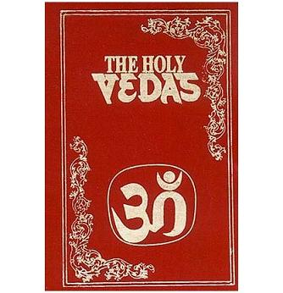
New Testament | The second part of the Christian Bible, that describes the life of Jesus Christ and the lessons that he learnt.
Gospel | The message concerning Christ, the kingdom of God and salvation.
Word of God | Something that God has decreed, something that God has said when addressing humans, words that God spoke through the prophets.
Decreed | An authoritative order having the force of law.
Translation | The process of translating words or text from one language into another.
Key skills
By the end of this unit, pupils are expected to be able to:
- Make links between Bible passages and Christian values, attitudes and beliefs.
- Use religious language to ask relevant questions.
- Talk about the work and perseverance of Bible translators.
- Describe what inspires and influences them.
- Describe the impact of the content of the Bible on believers’ lives.
- Use religious vocabulary to show understanding of religious texts.
- Make comparisons between the Bible and other holy books.

