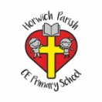 | RE Spring term 1 Year Four  Jesus the Son of God. How did Jesus show his power and authority?
Key vocabulary | Explanation/ definition | Key Knowledge
Son of God | Jesus the son of God | - Christians believe Jesus is the son of God he was both God and man.  - Christians believe Jesus has power and authority from God over every aspect of creation, life and death.  - There are people who have stood up and spoken out against authorities in situations of injustice.  - The Jewish holy day is Shabbat and there are many traditions and rules associated with Shabbat.  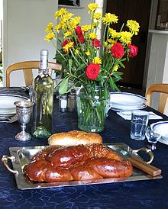
Authority | Power to command or control others.
Miracle | Wonderful and surprising event, believed to have been caused by God.
Sabbath | Day of worship and rest in some religions: Saturday for Jews and Sunday for Christians.
Shabbat | The name of the day of rest in Judaism. Shabbat happens on the seventh day (Saturday) of every week. In Judaism, the day is defined with the cycle of the sun: The day begins and ends at sunset, not midnight.
Pharisees | Members of an ancient Jewish sect, distinguished by strict observance of the traditional and written law, and commonly held to have pretensions to superior sanctity.
Key skills
By the end of this unit, pupils are expected to be able to:
- Retell the Bible stories covered in this unit.
- Make links between the Bible texts and Christian beliefs and values.
- Talk about people who have inspired them and why.

