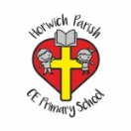 | RE Autumn Term 2 Year Three  Christmas God with us
Key vocabulary | Explanation/ definition | Key Knowledge
Emmanuel | This means ‘God is with us’ in Hebrew | - God is present with us all the time but we cannot see him.  - At Christmas we celebrate that he came to earth as a baby and lived among us (the people at that time) and was present in human form, the incarnation of God as a man.  - During World War II, a church in Strasbourg was bombed and much of it was destroyed. Not much remained except a heap of rubble and broken glass, or at least so the people thought until they began clearing away the rubble. There in the middle of all the mess they found their statue of Christ still standing erect. In spite of all the bombing it was unharmed - except that both hands that were raised in blessing were missing.
Incarnation | A person who embodies a God or deity in the flesh.
Jesus | The Son of God whose birthday is 25th December. Christmas is a celebration of his birth.
Nativity | The occasion of a person’s birth. We celebrate Jesus’ birth by reenacting a ‘nativity’ scene at Christmas.
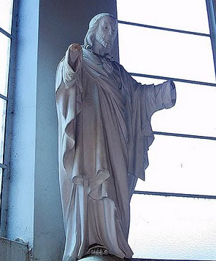
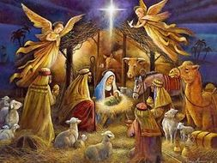

Key skills
By the end of the unit pupils will know that:
- Christmas is a celebration of the arrival of Emmanuel, who is Jesus God with us.
- we (Christians) believe God is with us through his Son, Jesus and the Holy Spirit.
- we (Christians) believe that the presence of God changes our lives.
By the end of the unit pupils will be able to:
- make links between their own experiences and the experiences of others.
- retell stories about the presence of Jesus changing people’s lives.
- describe the ways in which the actions of Christians show Jesus’ presence in the world.
- ask good questions about religious beliefs.

