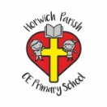 | RE Summer term 2 Year Two  What happened at the Ascension and Pentecost?
Key vocabulary | Explanation/ definition | Key Knowledge
Ascension | The act of ascending. The bodily ascending of Christ from earth to heaven. | - Christians believe that forty days after the resurrection, Jesus ascended into heaven.  - Christians believe that God is three in one – Father, Son and Holy Spirit.  - The gift of the Holy Spirit was poured out on the disciples at Pentecost and is here with us still.  - The events of Pentecost still impact on the church today.  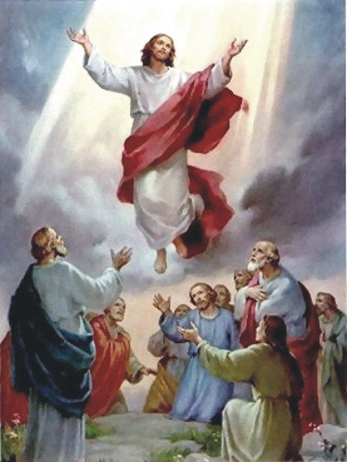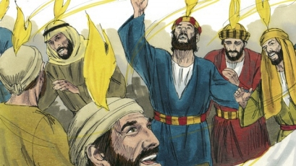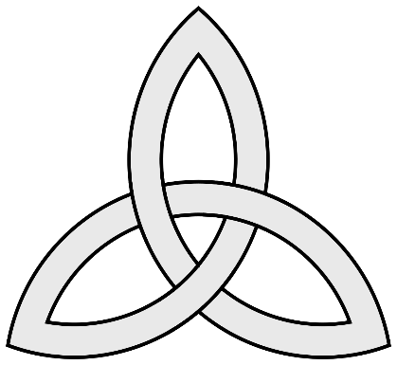
Pentecost | A Christian festival celebrated on the seventh Sunday after Easter, commemorating the descent of the Holy Ghost upon the apostles (disciples).
Holy Spirit | The spirit of God.
Disciples | The twelve special friends of Jesus.
Power | - Ability to do or act; capability of doing or accomplishing something.
Heaven | The home of God where people go when they die.
Trinity | The union of God the Father, God the Son and God the Holy Spirit in one God.
Key skills
By the end of this unit, pupils are expected to be able to:
- Retell the stories of Jesus’ ascension and the events of Pentecost.
- Talk about their ideas of heaven.
- Connect the gifts of the spirit with the school’s Christian values.
- Describe the symbols of the Holy Spirit.

