RE Summer term 1 Year One
Jesus was special
Key vocabulary | Explanation/ definition | Key Knowledge
Jesus | Jesus is the name of the man who Christians believe was the son of God, and whose teachings are the basis of Christianity. | - The stories of Jesus miracles can be found in the Gospels in the New Testament.  - Christians believe that the miracles reveal Jesus as the Son of God.  Calling His disciples Stilling the storm  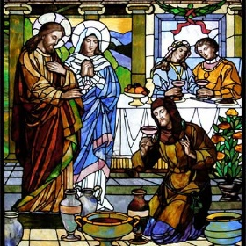  Feeding Five Thousand Turning water into wine
Son of God | Jesus is the Son of God
friendship | the state of being friends  the quality or state of being friendly
miracle | an unusual and mysterious event that is thought to have been caused by a god because it does not follow the usual laws of nature
disciple | a person who believes in the ideas and principles of someone famous and tries to live the way that person does or did
Key skills
By the end of this unit, pupils are expected to be able to:
talk about their own feelings and experiences.
ask and respond sensitively to questions about their own and others feelings and experiences.
retell stories of Jesus covered in this unit.
make the connection between the Bible stories and Christian beliefs about Jesus.

