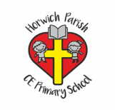 Art Knowledge Organiser Year 6 Drawing /painting Frozen Kingdom
Skills | Vocabulary/ techniques | Artists
Observe and use a variety of techniques to show the effect of light on objects and people  Look at the effect of light on an object from different directions.  Use a variety of techniques to interpret the texture of a surface e.g. mark making, different textured paint.  Produce increasingly detailed preparatory sketches for painting and other work.  Introduce the concept of perspective.  Work on a variety of scales and collaboratively.  Independently selects materials and techniques to use to create a specific outcome. | Water colour wash  Wet on wet  Wet on dry  Feathering  Lines/ hatching / cross hatching  Scrumbling  Stippling | Inuit art Kenojuak Ashevak 1927-2013  