Key vocabulary
heart | The heart pumps blood around your body.
pulse | Each time the heart beats it can be felt as a pulse in the arteries. Typically, in the wrist and neck.
blood | The red liquid pumped around the body by the heart. It transports oxygen, nutrients and water to all the parts of the body.
blood vessels | The narrow tubes which our blood flows through including the arteries, veins and capillaries.
lungs | Two organs situated in the ribcage that fill with air when you breathe in. They remove carbon dioxide from blood and add oxygen.
circulatory system | This circulates blood through the body. It consists of the heart, blood and blood vessels.
diet | The sort of food animals or humans regularly eat.
exercise | Activity that requires physical effort, carried out to sustain or improve health and fitness.
drugs | A medicine or other substance that has an effect in a person’s body.
lifestyle | The way in which a person lives.
Our pulse rate increases when we do exercise.

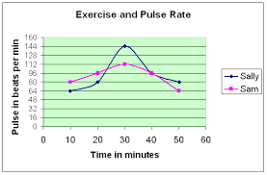
Animals including humans – Year 6
Significant scientist
William Harvey  (1578-1657)  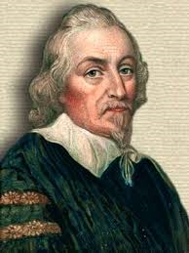 | William Harvey was an English physician and the first person to correctly describe blood’s circulation in the body. He showed that arteries and veins form a complete circuit.

Healthy bodies
Diet, exercise, drugs and other lifestyle choices have an impact on how our bodies function. This can affect how well our heart and lungs work and how fit and well we feel.
Some choices such as smoking, drinking alcohol and obesity can be harmful to our health:
Alcohol
Too much alcohol can damage the liver, heart and stomach.
Smoking
Can cause shortness of breath, heart and lung disease.

Why is exercise so important?
Exercise can increase fitness, make you feel physically and mentally healthier, strengthen your heart and improve your lung function.

© ECM Education Consultants 2019

The human circulatory system
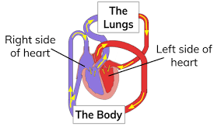
- The heart pumps blood in the blood vessels to the lungs where oxygen goes into the blood and carbon dioxide is removed.
- The blood goes back to the heart.
- It is then pumped around the body so that water, nutrients and oxygen are transported in the blood to the muscles and all the other parts of the body where they are needed. As all these are used, they produce carbon dioxide and other waste products.
- Carbon dioxide is carried by the blood in blood vessels back to the heart.
- The cycle starts again as the carbon dioxide is then transported back to the lungs to be removed from the body.
The circulatory system transports nutrients and water in the blood to all the parts of the body that need them. These nutrients provide us with energy.

Key vocabulary
vertebrate | Animals that have a backbone. They can be divided into 5 groups: fish, amphibians, reptiles, birds and mammals.
fish | - cold-blooded  - scales covering its body  - has fins  - lives in water, lays eggs in water  - breathes through gills
amphibian | - cold-blooded  - start as eggs in water and breathe through gills  - later develop lungs and live on land and in water  - lays eggs in water  - damp skin/body
reptile | - cold-blooded  - breathes with lungs  - dry, scaly skin  - lay soft-shelled eggs on land
bird | - warm-blooded  - breathes with lungs  - lays eggs with hard shells  - covered with feathers  - have wings but not all can fly
mammal | - warm-blooded  - have fur or hairy skin  - give birth to live young  - feed their young milk
invertebrate | Animals that do not have a backbone. Can be divided into several groups including insects, spiders, snails and worms.
plants | Can make their own food. They can be divided broadly into two main groups: flowering plants and non-flowering plants.
Living things and their habitats – Year 6
Significant scientists
Carl Linnaeus  (1707-1778)  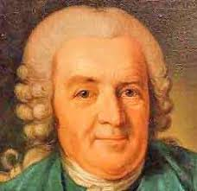 | Carl Linnaeus was a Swedish scientist who developed the modern system of classifying and naming organisms. Before this the names of living things were often very long. He gave them a two-part name.
Chris Nelson  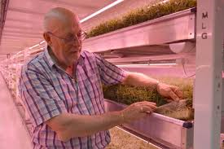 | Chris Nelson is a horticulturist and a director of Growing Underground which uses hydroponic techniques to grow pesticide-free crops in a former London underground air-raid shelter.
Classification
Living things can be classified into broad groups according to observable characteristics that are similar or different.

Micro-organisms
These are tiny living creatures. Most can only be seen through a microscope. They can be sub-divided into smaller groups including bacteria, fungi and viruses.

© ECM Education Consultants 2019

Flowering plants – numerous and diverse group. Reproduce through flowers and seeds. E.g. sunflower
Non-flowering plants – smaller group. They have a simple structure and do not have flowers or seeds. They reproduce through spores. E.g. algae, mosses

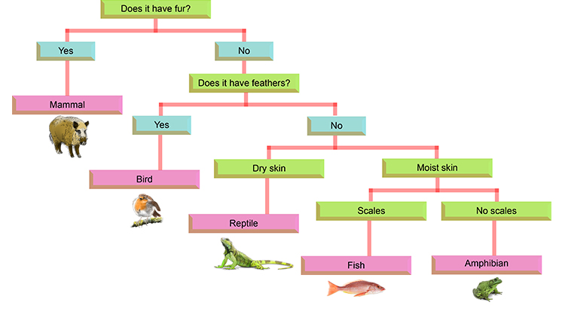
Classifying invertebrates
Classifying vertebrates
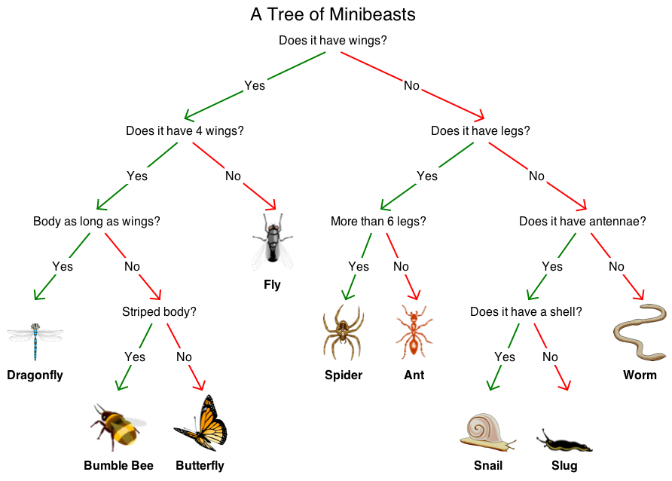
Key vocabulary
evolution | The way in which plants and animals have changed over millions of years.
offspring | A person’s child/children or an animal’s young.
inherited | The way a trait or characteristic is passed to offspring from parents.
characteristics | A distinguishing trait, feature or quality.
variation | A change or small difference.
adapted | Animals and plants are adapted to their environment. Their bodies are suited to the way they live.
environment | The conditions in which a living thing exists.
species | A group of closely related organisms that are very similar to each other. We are the human species.
fossil | The naturally preserved remains or traces of animals or plants that lived long ago.

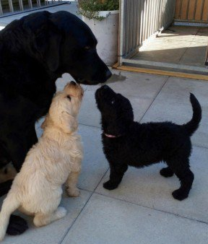
© ECM Education Consultants 2019
Living things produce offspring of the same kind. The offspring are not normally identical to their parents and vary from each other.
Evolution and inheritance – Year 6
Significant scientists
Charles Darwin  (1809-1882)  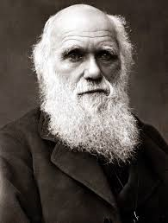 | Charles Robert Darwin was born in Shrewsbury and was an English naturalist and biologist. His scientific theory of evolution by natural selection became the foundation of modern evolutionary studies.
Alfred Wallace  (1823-1913)  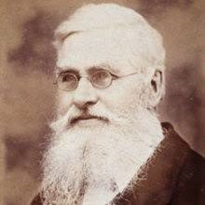 | Alfred Russel Wallace was an explorer, naturalist and anthropologist. He independently proposed the theory of evolution by natural selection. He worked around the world gathering evidence to support his theory.

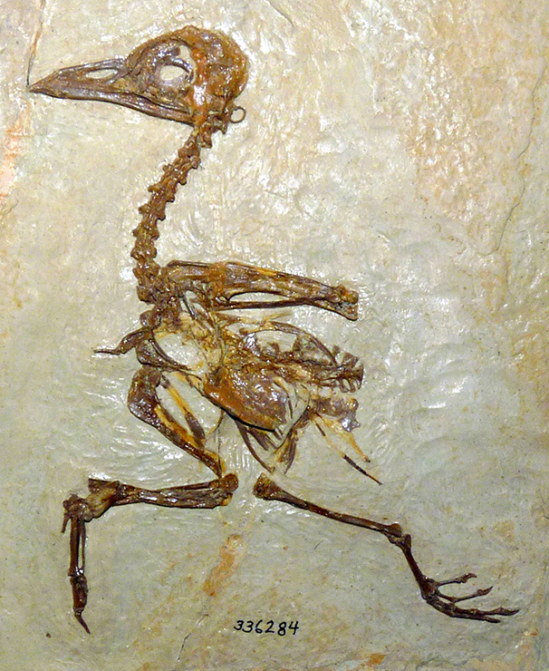
Fossils give us evidence of what lived on the Earth millions of years ago.
By studying fossils, scientists can put together how a plant or animal looked. They can identify what the animal ate, where it lived and how it died.

Adaptation
Plants and animals have characteristics that make them suited to their environment. E.g. camel:
nostrils that can close
long eyelashes
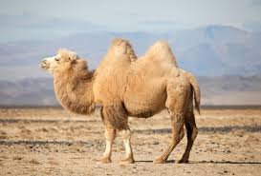
humps to store fat
camouflaged body colour.
thick, rubbery lips
wide feet

Evolution
Adaptation can lead to evolution if the environment changes. Animals and plants with variations that are best suited survive in greater numbers to reproduce and pass their characteristics on to their young. This is natural selection. Over time these inherited characteristics become more dominant within the population.
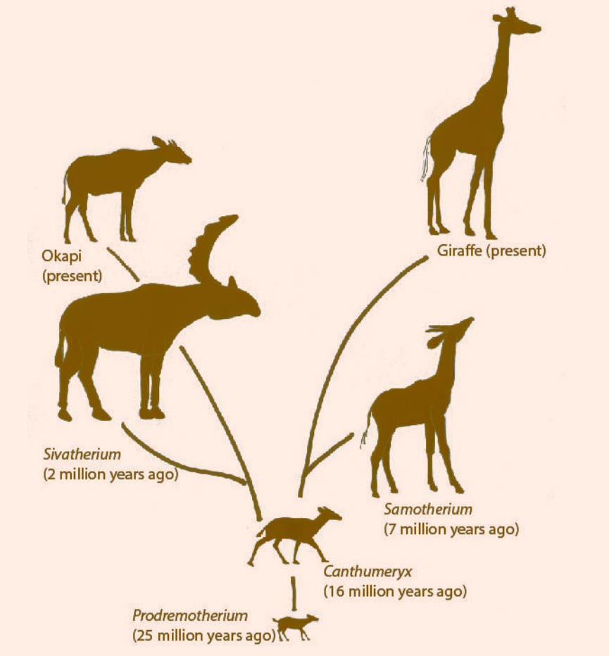
Giraffes have evolved to have a longer neck through natural selection. This means they can reach food on the higher branches of trees.
Key vocabulary
light source | A natural or artificial source of light.
straight lines | Light travels in straight lines.
light ray | Each line of light travelling in a straight line from its place of origin.
reflect | To throw back light from a surface.
shadow | A dark area created where light from a light source is blocked by an object. The object blocking the light will be opaque or translucent.

Light travels in a straight line:
We can use an arrow to represent the path of the light.

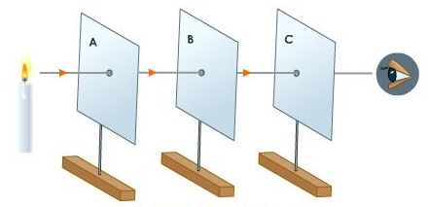
Light source
We see light from the light source when it enters our eyes.

© ECM Education Consultants 2019
Light – Year 6
Significant scientists
Abu Ali al-Hasan  (Alhazen)  (965-1040)  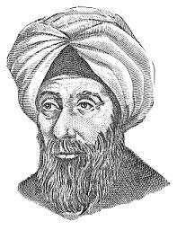 | Alhazan was an Iranian mathematician, astronomer and physicist. He was the pioneer of modern optics. He carried out experiments with pinhole cameras and candles and explained how the image is formed by rays of light travelling in straight lines.
Ben Jensen | Ben Jensen is an inventor at Surrey NanoSystems Ltd and developed Vantablack, a super-black coating that holds the world record as the darkest human-made substance.
shadow
Light may come directly from a light source.
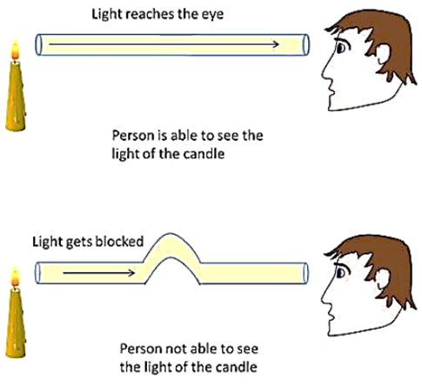
For objects that are not a light source, light must be reflected from the object into our eye for us to see the object:
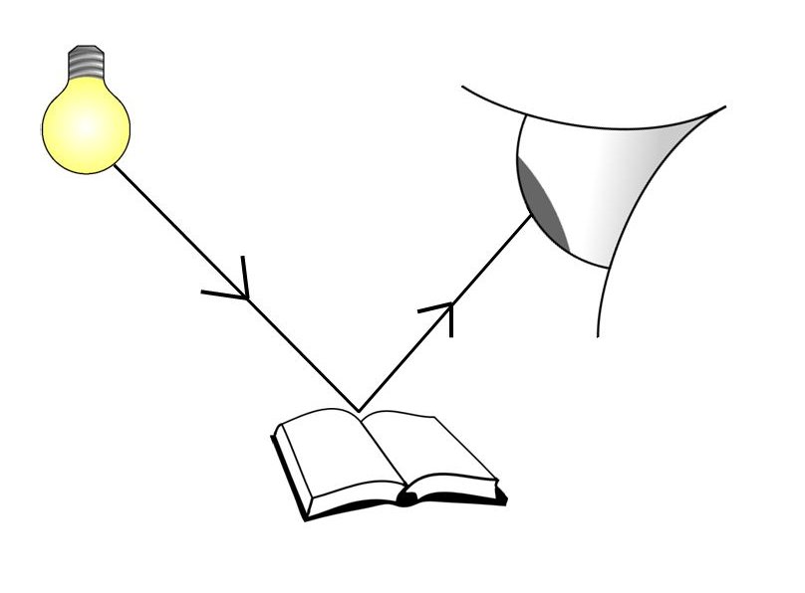
Shadows have the same shape as the objects that cast them:
Light travelling in a straight line.
Opaque object blocking the light.

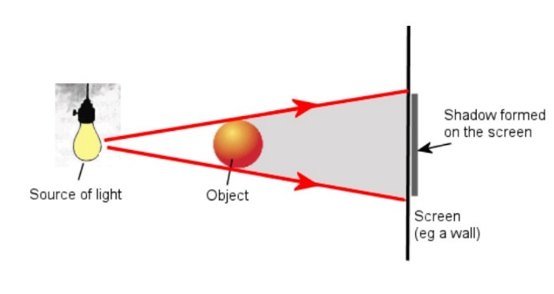
Key vocabulary
circuit | A complete path that an electric current can flow around. It flows from the battery, through wires and devices before returning to the battery. If the circuit is not complete the electric current cannot flow.
circuit symbol | A symbol used to represent various electronic components or functions in a diagram of a circuit.
circuit diagram | A visual representation of an electrical circuit using symbols to represent the electrical components.
cell | A single electrical energy source.
battery | A device consisting of one or more cells.
switch | An electrical component that can make or break an electrical circuit. When a switch is open (off), there is a gap in the circuit and electricity cannot flow around the circuit.
voltage | Volts are a measure of the energy of a flow of electricity. Mains electricity carries a voltage of 210-240 volts. A typical cell in school has 1.5 volts.

Switch turned off (open).
This breaks the circuit so it is not complete and electricity cannot flow. The bulb will turn off.

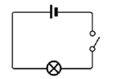
© ECM Education Consultants 2019
Electricity – Year 6
Significant scientists
Nicholas Tesla  (1856-1943)  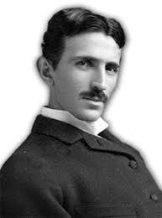 | Nicholas Tesla was a Serbian-American engineer and physicist. He invented the first alternating current (AC) motor and developed AC generation and transmission technology. He worked for Thomas Edison when he first moved to New York.
Peter Rawlinson  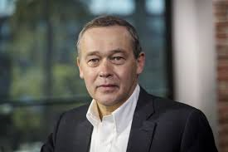 | Peter Rawlinson is a British engineer based in California. He is working on the development of electric vehicles, providing clear vision for a next-generation product.

Circuit symbols
cell
battery | 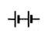
wire
bulb
buzzer
motor
switch | 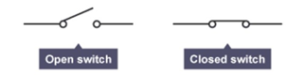

Adding more cells to a circuit makes a bulb brighter:
The bulb in this circuit will be brighter.

If you use a battery with a higher voltage, the bulb would also be brighter.

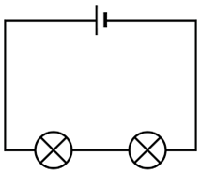
Adding more bulbs to a circuit will make each bulb less bright.
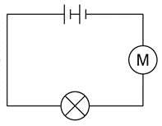
If we add a motor into a circuit with a single bulb, the bulb will be less bright.
If we then add more motors to the circuit, each motor will spin more slowly.

