Key vocabulary
digestive system | The organs in your body involved in the digestion of food.
digestion | This is the way the body breaks down food so the body can absorb it.
herbivore | Animals that only eat plants.
carnivore | Animals that eat other animals.
omnivore | Animals that eat both plants and animals.
producer | All green plants can make food in their leaves. They are the only producers of food.
consumer | Animals that eat plants in a food chain.
predator | Animals that catch and eat other animals.
prey | Animals that are hunted and eaten by predators.
food chain | Animals eat plants or other animals. The way this happens is shown in a food chain.

Teeth
Humans have 4 types of teeth:
- incisors – used for cutting
- canines – rip and tear food
- molars and premolars – for grinding and chewing food

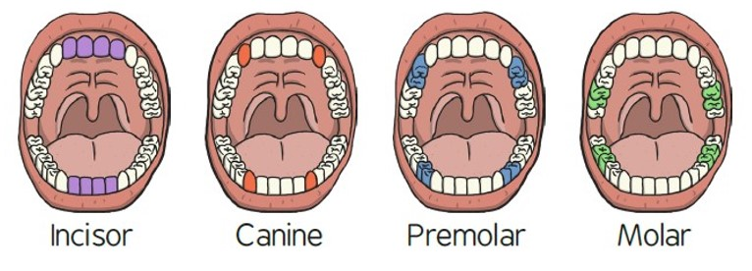
Animals including humans – Year 4
Significant scientist
William Beaumont  (1785-1853)  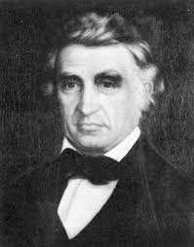 | William Beaumont was a surgeon in the U.S. Army. He carried out lots of experiments and research on human digestion.  As a result, he provided the world with new information about the digestive process in living human beings.

Food chains
= is eaten by
algae  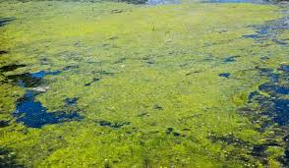 | tadpole  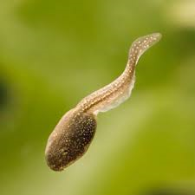 | fish | stork  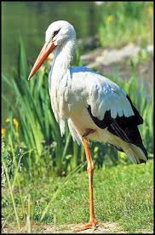
grass  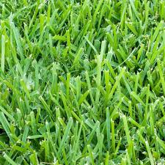 | beetle | mouse  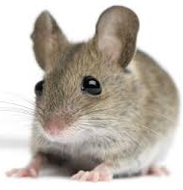 | fox  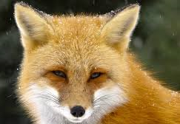

Lion skull
Lions are carnivores. They have big canine teeth to help them catch their prey.
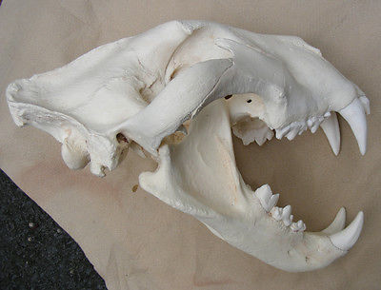
© ECM Education Consultants 2019
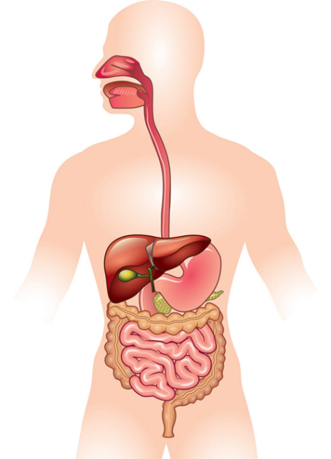
anus
large intestine
stomach
rectum
small intestine
oesophagus
mouth and teeth
The main parts of the digestive system:
- Food enters the body through the mouth
- The teeth start to break the food down. Saliva is added and the tongue rolls the food into a ball.
- After swallowing, the food passes down the oesophagus to the stomach
- In the stomach the food is broken down further by being churned around and some chemicals are added.
- Food passes into the small intestine. Here nutrients are removed from the food to be used elsewhere in the body.
- The rest passes into the large intestine where water is removed to be used elsewhere in the body.
- What is left is then stored in the rectum until it leaves the body through the anus when you go to the toilet.
Key vocabulary
classification | Grouping things based on their characteristics so that they can be identified.
classification key | A series of yes/no questions that help identify or classify things.
environment | The conditions in which a living thing exists. Soil, climate and other living things all count as part of the environment.
habitat | The place where an animal or plant lives.
migrate | The long-distance movement of animals, usually due to a change in the seasons.
hibernate | An animal or plant that spends the winter in a dormant state.
vertebrates | Animals that have a backbone. Fish, amphibians, reptiles, birds and mammals.
invertebrates | Animals that do not have a backbone. Examples are snails, worms, spiders and insects.
© ECM Education Consultants 2019
How can environments change?
Natural changes | This could be caused by flooding, fire, earthquakes etc
Human have an impact on the environment:
Positive impact  This could be:  - setting up a nature reserve  - tree planting  - creating a garden pond. |  | Negative impact  This could be:  - littering  - deforestation  - air pollution  - plastics in the oceans
Living things and their habitats – Year 4
Significant scientists
Jane Goodall  (Born 1934)  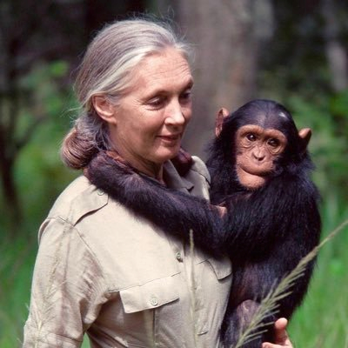 | Jane Goodall is an expert on wild chimpanzees. She is known for her ground breaking discoveries about their behaviour. She has shown us the urgent need to protect chimpanzees from extiction.
Seirian Sumner | Dr Seirian Sumner is an evolutionary biologist and behavioural ecologist. She specialises in social evolution and behaviour in insects (bees, wasps and ants).

Environments can change with the seasons:
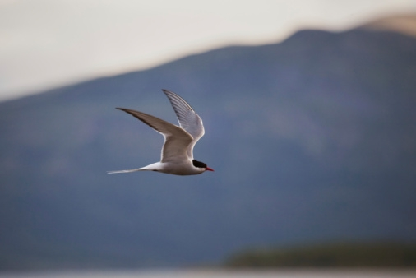
Arctic tern migrates from the Arctic to Antarctica.

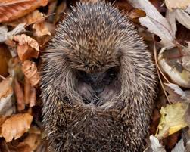
Hedgehogs hibernate in the winter in small, dry, sheltered places, like tree roots.

Classification keys
A key to sort leaves
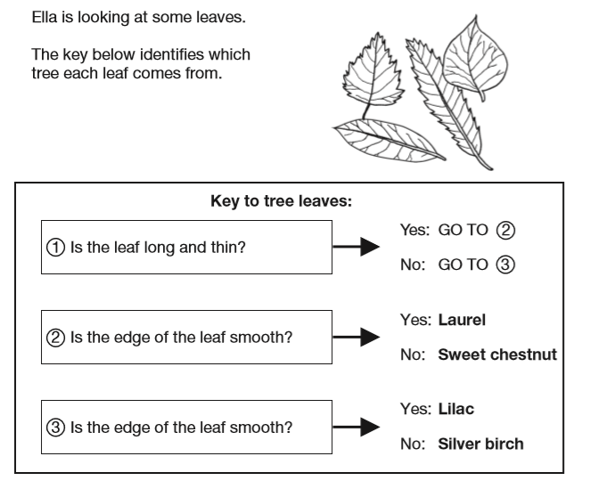
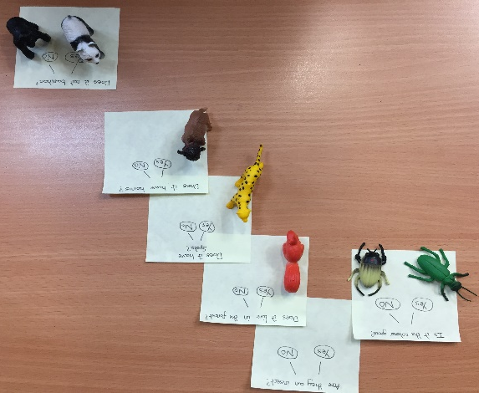
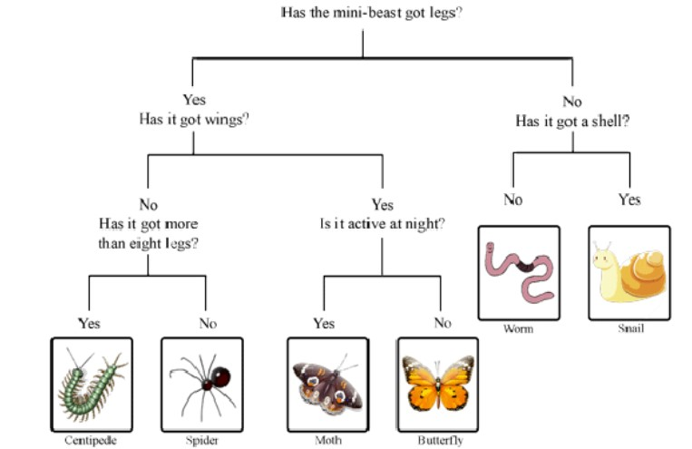
ey Vocabulary
electricity | A form of energy used for lighting, heating, making sound and making machines work.
electrical appliance | A machine or device that runs on electricity.
mains | The electricity supplied to households from power stations.
electrical circuit | This consists of a cell or battery connected to a component using wires. It needs to be a complete circuit to work.
cell and battery | A cell is a single unit and a battery is a collection of cells.
electrical component | A part that combines with others to form a circuit. E.g. bulb, motor, buzzer
switch | Can be added to a circuit to turn a component on or off. It allows the electricity to flow or it stops it.
conductor | Material that allows electricity to pass through.
insulator | Material that does not allow electricity to pass through it.

Appliances that run on electricity
Some plug into the mains and others run on batteries.
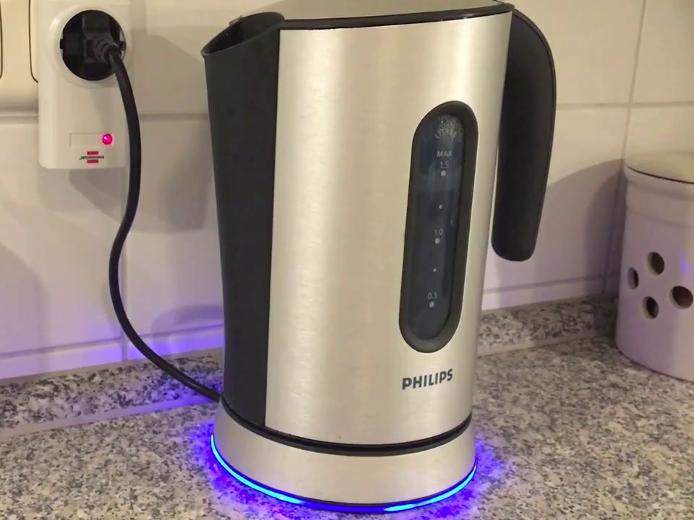 | 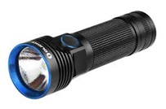
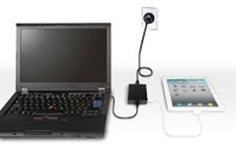 | 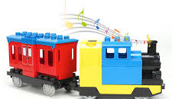
Electricity – Year 4
Significant scientist
Thomas Edison  (1847-1931)  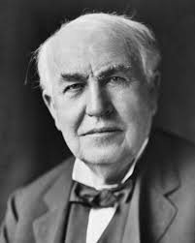 | Thomas Edison was an American inventor. He is sometimes described as America’s greatest inventor. He invented the first practical incandescent light bulb.

Electrical circuit with a bulb
switch
cell

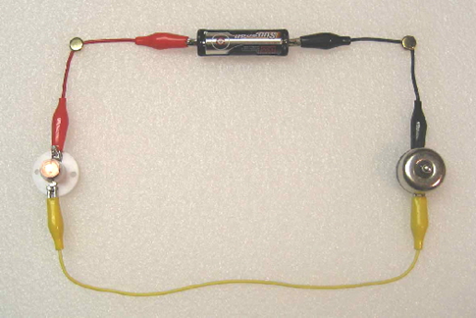
wire
bulb

The switch opens and closes the circuit. The bulb lights in this circuit because the switch is on.

© ECM Education Consultants 2019
This circuit will not work as it is not complete. | 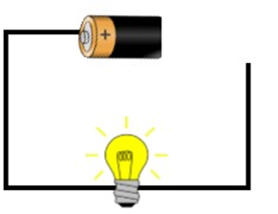
This circuit is complete so the buzzer will sound and the bulb will light. | 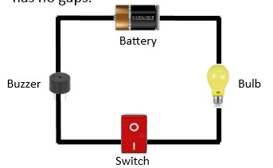

Conductors and insulators
Conductors
Some materials let electricity pass through them easily. These are known as electrical conductors. Many metals are good electrical conductors, such as iron, copper and steel.
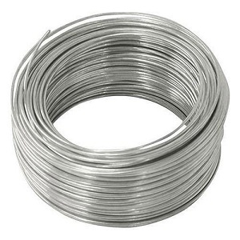 | 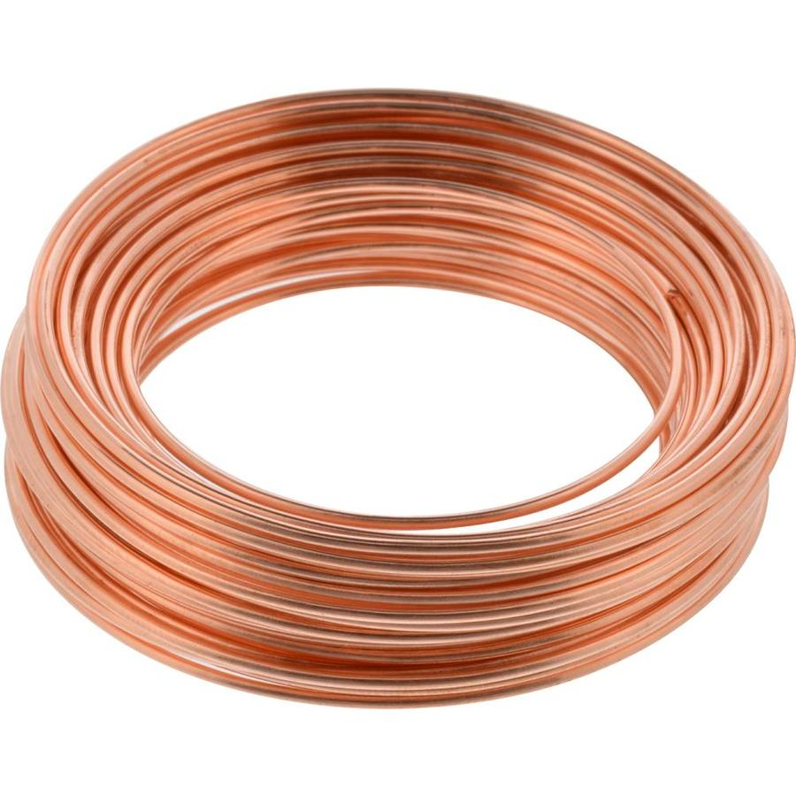
Insulators
Some materials do not allow electricity to pass through them. They are known as insulators. Plastic, wood, rubber and glass are good electrical insulators.
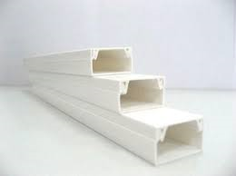 | 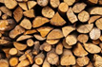
Key vocabulary
sound | Something you can hear or that can be heard. We hear sound with our ears.
sound source | A source is producing sound when some part of it is vibrating.
vibrations | Sounds are made when something vibrates. This means it moves quickly backwards and forwards.
pitch | How high or low a sound is.
volume | How loud or quiet a sound is.
sound insulation | A material which blocks sound effectively.

How do we hear sound?
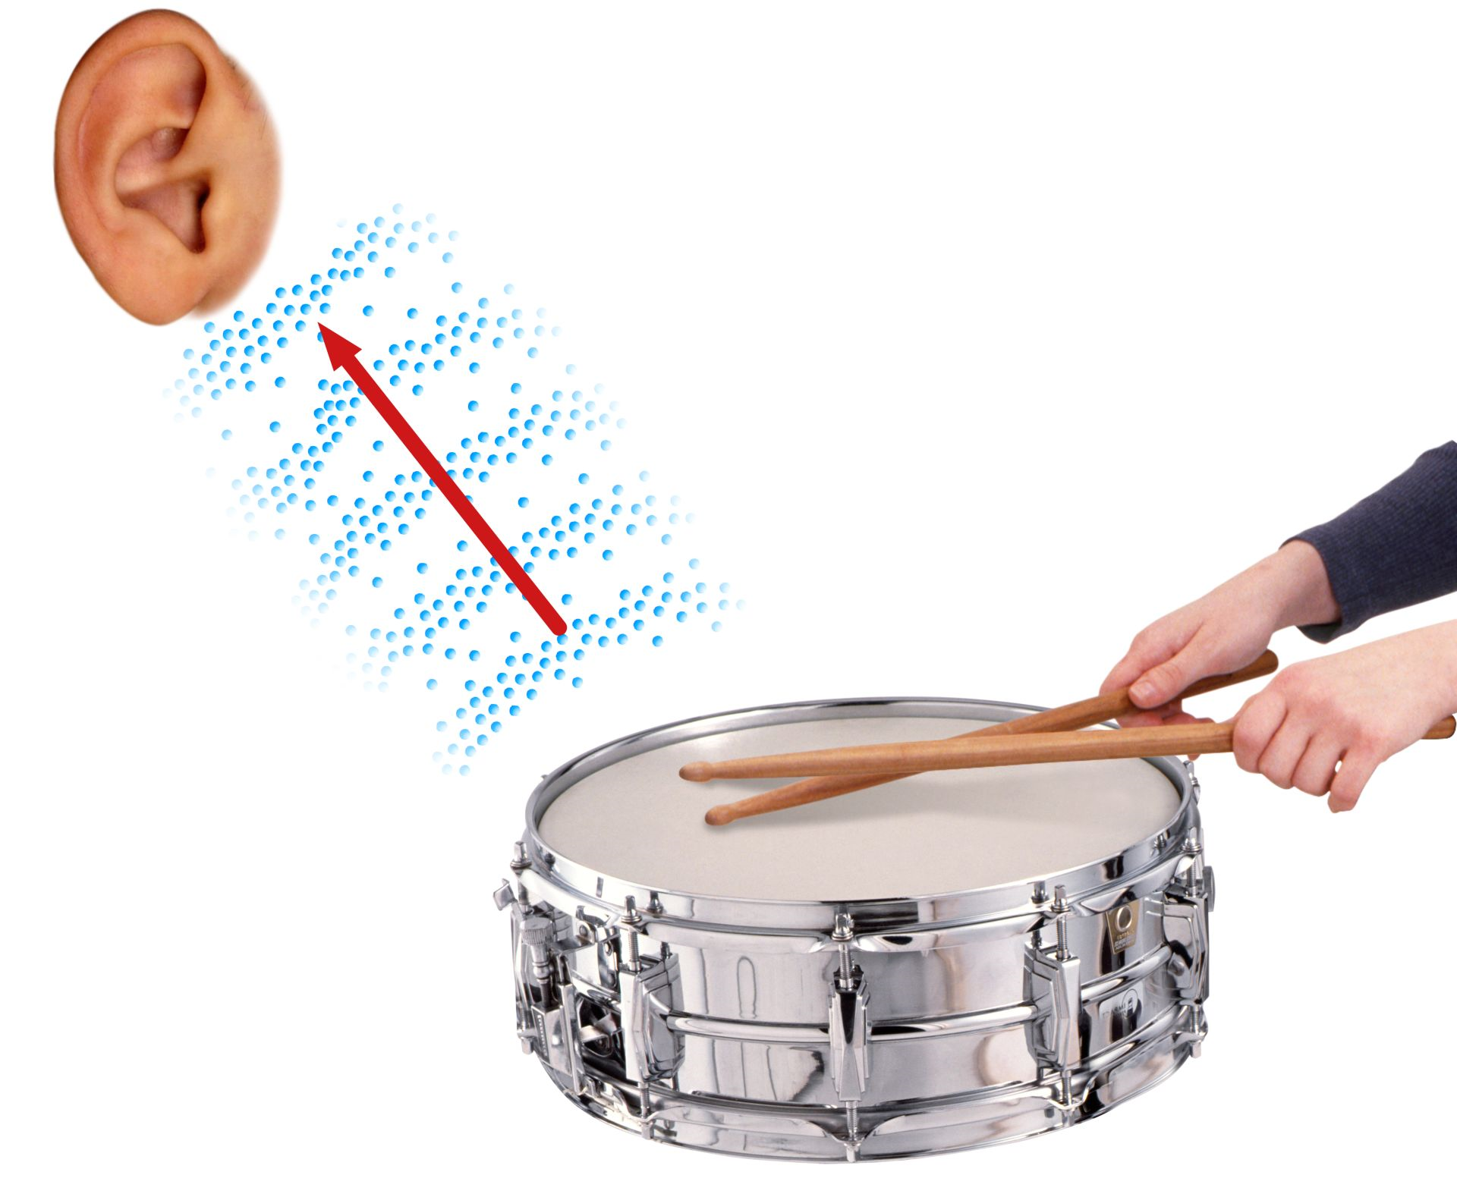
1. Banging the drum produces vibrations.
2. The sound travels through the air to our ears.
3. The vibrations cause parts of our body inside our ear to vibrate. This allows us to hear the sound.

© ECM Education Consultants 2019
Sound – Year 4
Significant scientist
Christian Doppler  (1803-1853)  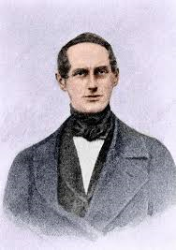 | Christian Doppler was an Austrian mathematician and physicist. He is celebrated for his principle known as the Doppler effect. This describes how noises sound different as you move toward or away from a noisy object.

As well as travelling through air (gas), sound can travel through solids and liquids:
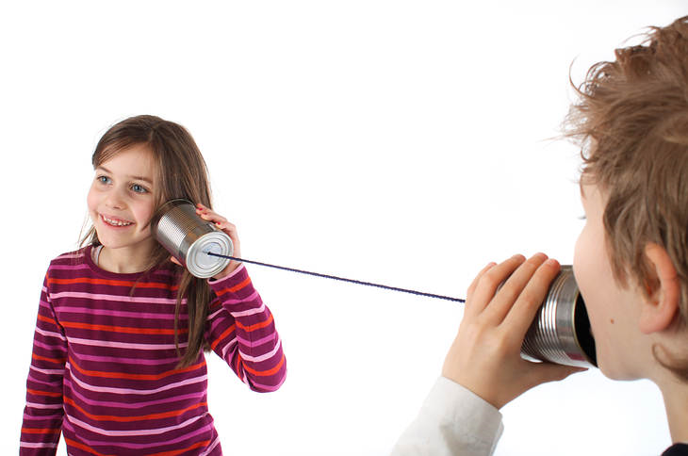 | 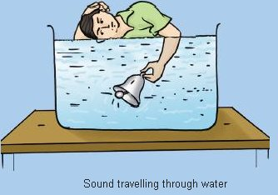

Pitch
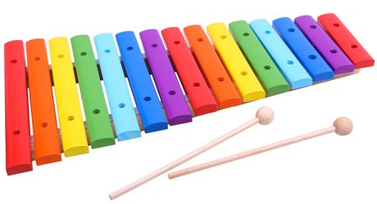
The longer bars on the xylophone make a lower sound. | The shorter bars on the xylophone make higher sounds.

Volume
The volume (loudness) of a sound depends on the size of the vibrations.
If we blow an instrument harder, we make a louder sound.
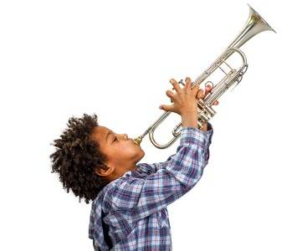

The closer we are to the sound source the louder it will be.
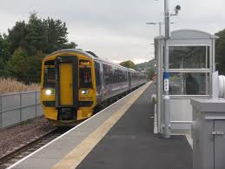 | A train arriving at a station sounds loud.

The further away from a sound the fainter it will be.
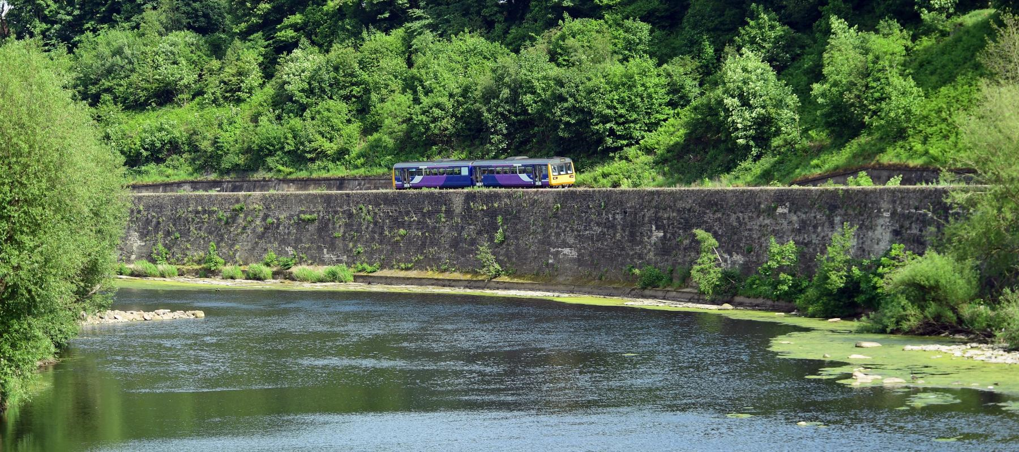 | A train in the distance sounds quieter.

Insulating sound
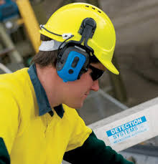 | We can wear ear defenders to protect our ears from very loud sounds.

Key vocabulary
change of state | When a material changes from one state to another.
melting | A solid changing into a liquid.
freezing | When a liquid becomes cold enough to turn solid, it freezes.
melting point | The temperature at which a solid becomes a liquid.
boiling point | The temperature at which a liquid turns into a gas.
evaporation | When liquid changes into a gas.
condensation | The process when a gas changes into a liquid, caused by cooling.
water cycle | The never-ending process of water moving from the oceans, up into the atmosphere, and back to the Earth and oceans.
temperature | The measure of how hot or cold something is.

Solids, liquids and gases
A solid keeps its shape and has a fixed volume.
ice | 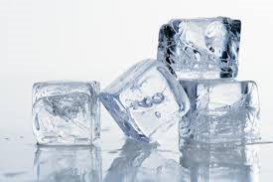 | sugar | 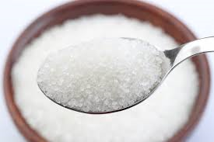
A liquid has a fixed volume but changes in shape to fit the container. It can be poured.
water | 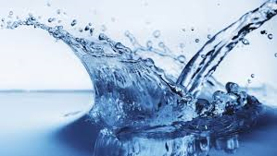 | honey | 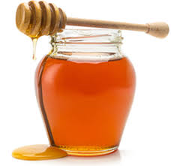
A gas fills all the available space; it has no fixed shape or volume.
water  vapour | 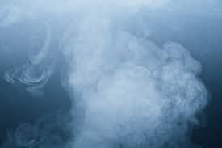 | bubbles in cola | 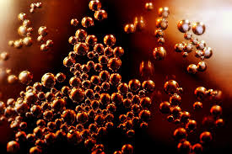
States of matter – Year 4
Significant scientist
Bernard Palissy  (1510-1590)  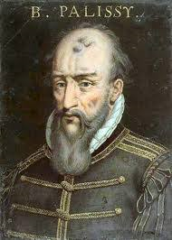 | Bernard Palissy was a French potter and scientist. He is often credited as the man who ‘discovered’ the modern theory of the water cycle. He asserted that rainfall alone was sufficient for the maintenance of rivers.

Melting and freezing
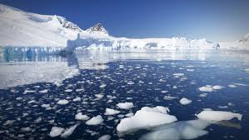 | Melting is a change of state from solid to liquid. The melting point of water is 0°C.
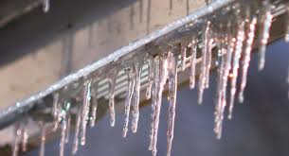 | Freezing is a change of state from liquid to solid. The freezing point of water is 0°C.
Boiling is a change of state from liquid to gas. Water boils when it is heated to 100°C. |  | 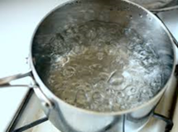

Evaporation and condensation
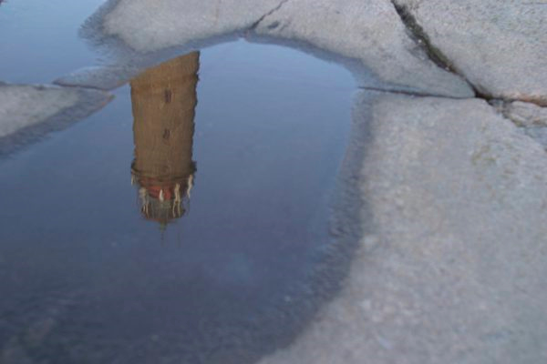 | Evaporating puddles  Evaporation is the change from a liquid to a gas at the surface of the liquid.
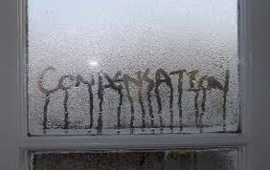 | Condensation in the bathroom  Condensation is the change from a gas to a liquid, caused by cooling.

The Water Cycle
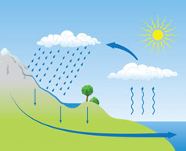
c
a
b
d
a | Water evaporates into the air  The sun heats up water at the surface of seas, rivers, lakes and turns it into water vapour. The water vapour rises into the air.
b | Water vapour condenses into clouds  Water vapour in the air cools and changes back into tiny drops of liquid water, forming clouds.
c | Water falls as rain snow, sleet etc  When too much water has condensed the water droplets in the clouds get too heavy and water falls back down to Earth in the form of rain, snow, sleet etc. This is called precipitation.
d | Water returns to the sea.  Rainwater runs over the land and collects in lakes or rivers which take it back to the sea.  The cycle starts all over again
© ECM Education Consultants 2019

