Promoting SMSC and British Values through Science at Horwich Parish CE Primary School
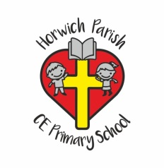
SMSC Spiritual Education
- Looking for meaning and purpose in natural and physical phenomena
- Wonder about what is special about life
- An awareness of the scale of living things from the small micro-organism to the largest
- The interdependence of all living things and materials of the Earth.
- Emotional drive to know more and to wonder about the world
- Wonder at the vastness of space and the beauty of natural objects
Moral Education
- Pupils to become increasingly curious
- Development of open mindedness to the suggestions of others
- Scientific developments may give rise to moral dilemmas
- Considering the environment
Social Education
- Group practical work
- Team working skills and to taking responsibility
- Taking responsibility for their own and other people’s safety
- Understanding that science has a major effect on the quality of our lives
- Consider the benefits of scientific developments and the social responsibility involved
Cultural Education
- Scientific discoveries as a part of our culture
Scientific discoveries of other cultures
- Scientific discoveries by a wide range of men and women in many different cultures
- Environmental issues are central to science

British Values
Democracy
- Take the views and opinions of others into account
- Take turns and instructions from others
The rule of law
- Understand the importance of safety rules when working scientifically
- Know that there are consequences in rules are not followed
Individual liberty
- Make choices when planning an investigation
- Others may have different points of view as to where to start
Tolerance
- Scientific discoveries have come from other cultures
- Religious beliefs often compete with scientific understanding
Mutual respect
- Work as a team
- Discuss findings
- Offer support and advice to others

