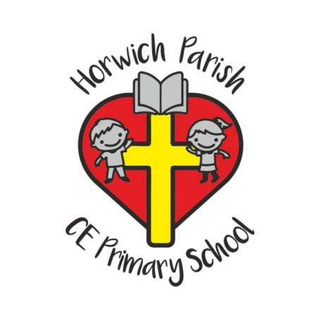

Protocol on sickness and infections in school

Horwich Parish CE School is required to follow advice on reducing the spread of infections including bugs causing vomiting and diarrhoea. This is the agreed advice of GPs, school nurses and public health. It is particularly important to follow this advice in the case of young children, who are still learning effective personal hygiene, and who come into close contact with each other.
Experience shows that if ALL parents keep to this advice, children recover more quickly and avoid re-infecting each other. It is also important that the spread of infections to staff members is avoided whenever possible.
The advice to follow is:
Vomiting or diarrhoea
Your child should not return to school after vomiting or diarrhoea until 48 hours after the symptoms have stopped.
We also require parents to collect children promptly from school if such symptoms begin at school.
Head lice

If head lice are detected whilst in school we will contact parents and ask where possible that children are treated and returned to school as soon as possible. There is no reason for your child to be off school once treated and the absence will not be authorised.

Thank you for your understanding.

