Parent/Carer Bereavement Support Booklet

Contents

Children’s Understanding of Death 2
The Stages of Grief 4
How to Talk to Children About Death 6
Useful Websites and Resources 8
Books on Bereavement (Primary) 12
Books on Bereavement (Secondary) 17
Social Stories about Death and Bereavement 19

Children’s Understanding of Death

Adults and children feel the same loss when a loved one dies, but their reactions can be noticeably different.
Children themselves react in different ways to a loss, depending on their age and stage of development. The worst loss of all, at any age, is that of bereavement.

Age | Thought Processes | Emotional Responses | Behaviour Responses
Early years | Unable to grasp the permanence of separation. When a child experiences the loss or death of a primary carer the child will need help in coming to terms with the irreversibility of the situation. Children at this age may confuse death with sleep. Their view of the world is still highly egocentric and they need reassurance if they feel that they are in some way responsible. Questions they have are best dealt with honestly and factually and euphemisms for death are best avoided. | Children may become anxious about themselves or the lost loved one. There may be yearning and searching for the person who is not there although expression of sadness may be short-lived. Children at this age react strongly to the emotions of the adults around them. They may be very anxious when separating from the surviving parent. | Children may be clingy and/or regress in some aspects of their development and behaviour, eg thumb sucking, bed wetting, soiling etc. Sleep may be disturbed and children are believed to be more prone to infections and other illnesses following the death of a parent. More disturbed behaviour may be evident in children who have not yet developed language abilities to talk about and understand what has happened to them.
5 to 7 | The permanence of death may still not be established and this is still a stage of ‘magical’ (irrational) thinking.  Children may have clearer ideas of the concepts of ‘life’ and ‘death’, eg death means separation. They are likely to ask more relevant questions about death. | Children at this age may be more distressed and for longer periods, eg excessive crying. There may be anger or feelings of guilt. Many children may, however, carry on as if nothing has happened. | Children may act out death and dying. They may be particularly restless in school and at home. Psychosomatic symptoms, eg ‘tummy aches’ and sleep disturbance may be evident. The child may have fantasies about the lost loved one and daydreaming may be particularly apparent.
8 to 11 | Children now understand the permanence of death but there still may be confusion about metaphors and euphemisms used to describe death. There is now a realisation that death can occur to the child him/herself. The child has greater capacity to reason in a logical way about what happened and to be more objective. | There may be anxiety about self or other people dying. Feelings of sadness may last longer. They are now more able to empathise with others and support them. The child may be anxious about separating from a surviving parent, eg reluctant to come to school and high levels of reassurance are needed. | There may be significant changes in behaviour, with children internalising or externalising their feelings. Anger and aggression may be more apparent. Nail biting, sleep disturbance and physical illness may occur.
Adolescence | Adolescents can usually think in abstract terms and they may ask more detailed questions about death. They are now able to understand the longer-term consequences of death and now have a more adult understanding of death and life and death cycles in nature. They may develop their own theories about death and life after death. They may become interested in ethical issues such as abortion or euthanasia. | Bereavement at this age can generate a whole range of emotional responses. Teenagers’ emotional reactions are often stronger and wider ranging. They may worry about the future and they may feel depressed and lonely. Boys may be less able to talk about their feelings. Teenagers can experience feelings of survival guilt. | Teenagers who experience bereavement may internalise their grief and distress, eg eating disorders, self-harm, physical illness, disturbed sleep, etc. Alternatively, the bereaved teenager may try to shut out or express their feelings by externalising their concerns through challenging behaviour, increased risk-taking behaviour, conflict, use of alcohol or drugs etc.

The Stages of Grief

Grieving takes people through many different emotions; the grieving process will take its natural course. It is accepted that when we grieve, we may go through several different stages, though we can move backwards and forwards through them, or perhaps not go through all of them. These are:
- accepting the reality of the loss
- experiencing the pain of grief
- adjusting to the changes that have occurred
- being able to invest in new relationships.

The grieving process for any loss can be the most difficult and painful stage to go through and a wide range of feelings and behaviours may occur, not always in any predictable order. Grieving can cover a wide variety of feelings.

Feeling | What do children need and  what we can do to help
Anxiety  If a child loses someone on whom they are largely dependent for their wellbeing they can experience strong feelings of insecurity and anxiety. | - Reassurance that their world has not disintegrated  - Information or honest answers to their questions  - Patience and support from the people around them  - Time to adjust to a new way of life  - Routines and stability at home and school  - Language which is straightforward and easily understood  - Time to accept their emotions as well as time to express them
Anger  Feelings of anger are often experienced by children and young people after a loss and this can be externally directed or directed on themselves. Managing their feelings of anger can be particularly frightening for children. | - A safe place to express their anger and confusion  - Adults who are prepared to listen and who acknowledge their grief  - Reassurance that they were not responsible for what happened  - Time to adjust to what has happened  - Familiar routines and lifestyles  - Adults who will admit they don’t know all the answers
Denial & disbelief  Such feelings often occur immediately when bad news is given such as the death of a significant person. Feelings of numbness can be an initial defence mechanism to protect the child from the emotional trauma they are experiencing. Shock and numbness may last for several hours before reality breaks through. | - To be told the facts about what has happened as clearly and concisely as possible and in language they understand  - Familiar routines and safe surroundings  - People who will help to keep the memory of the person ‘alive’  - To be allowed to express their responses in a way which is right for them as long as they are not endangering themselves or anyone else
Strong visual association & sleep disturbance  Research suggests that in experiencing emotional trauma sensory impressions can be more powerful and, particularly where language development is not complete, powerful sensory images may be associated with the trauma. Strong visual images may recur particularly at night. Sleep disturbances can also be triggered by adults euphemistically referring to death as sleep. | - Language that describes death in a way that is understood  - Reassurance that they are ‘safe’ as they sleep  - Opportunities to act out or role-play their anxieties or experiences  - Information and honest answers to their questions
Sadness & longing  Such feelings may last for only a short period but they can be very intense and painful. | - A ‘safe’ place to express their emotions  - Opportunities to role-play their experiences and emotions  - Continuity in care at home and at school  - Adults who will comfort them and help them express how they feel
Children can sometimes experience feelings of guilt & self- blame | - Reassurance that they were not to blame either through thought or neglect  - Time to adjust to what has happened  - Opportunities to express their anxiety, for example through counselling or therapy  - Opportunities to give a ‘last message’ to say what they would like to have told the deceased person before they died, to ‘repair’ something they wish they hadn’t said etc.

How to Talk to Children About Death
Children respond differently to adults. Depending on their age and stage of development they may seem sad then suddenly be happy and playing. This is a normal reaction and should be encouraged. Some children will react a lot, other children won’t show much of a reaction at all. This is also OK.

Do:
- Tell children as soon as possible so they don’t find out from someone else.
- Answer all questions as honestly as you can and encourage questions when they are ready – it’s also ok to say you don’t know if you don’t know the answer.
- Use simple language e.g. dead, passed away – maybe link it with a death they have experienced (eg an older relative, a pet).
- Check they have understood what has happened but keep it simple.
- Tell them it’s OK to laugh or cry (no matter how old they are).
- Feel Ok to cry in front of your child if you need to, but try not to offload your grief onto them.
- Answer the same question several times even if it is the same one (you may need to tell the story over and over again).
- Reassure them it is not their fault.
- Encourage them to talk to you as much as they want to. Some children bottle up their feelings because they don’t want to upset you or others in their family
- Let your child know that it’s OK to talk when they are ready. There is no ‘right’ or ‘wrong’ time to talk about it. Children may talk at bedtime because it’s a quiet time and they may need more reassurance at bedtime.
- Allow your child to express themselves in other ways eg drawing, if they don’t want to talk.
- Expect children to show their grief through behaviour changes – this is a normal response.
- Offer them the phone number of a support service if they feel they want to talk to someone outside of the family – see ‘Useful Websites and Resources’ below. If you are very worried about your child ring your GP or out of hours surgery.
- Balance your child’s emotional wellbeing along with the work they are doing at home.

Try Not To:
- Try not to be afraid to use the person’s name and talk about them.
- Don’t use confusing language e.g. “gone to sleep”, “gone away”,” not with us” “lost them” – this may make them feel afraid of bedtime or losing something.
- Try to tell them they are too young to know or understand.
- Try not to see it as attention seeking as all children will need to express their feelings.

Things Children Can Do Which May Help
- Drawing themselves with the person if they knew them.
- Write stories or poems about the person.
- Listening to music that reminds them of the person or listening to music that makes them feel happy.
- Having a photograph of the person.
- Having something they gave you may help.
- Making a memorial (eg a plant).
These things could also go in a ‘memory box’

Useful Websites and Resources

Local support services
Bolton Bereavement Service for Children and Young People:
https://boltonladsandgirlsclub.co.uk/targeted-youth-services/bolton-bereavement-service-for-children-and-young-people/
Bolton Lads and Girls Club provide a single point of access for children, young people (8 – 18 years) and their families who have experienced bereavement and are identified as requiring extra support. Referrals are made to bereavement@blgc.co.uk using the referral form on their website.

Chat Health (Tel: 07507 331753)
A confidential texting service for anyone aged between 11 and 19 (25 if a Care Leaver or have SEND) who lives or goes to school in Bolton. Young people can text a Bolton Public Health Nurse anonymously for support on a range of topics including mental health, bullying, smoking, drugs, sexual health, bereavement, relationships and much more. To use Chat Health they simply text their message to the number above and will get a reply within 24 hours.

Kooth www.kooth.com
Kooth is for young people in Bolton aged 11-25 and offers anonymous 1:1 text-based counselling, self-help support, moderated peer support forums and 24-7 messaging function available 365 days a year. Schools in Bolton can also request virtual or face to face sessions for pupils and / or staff by contacting Heather Hook (Kooth’s Integration and Participation Worker for Bolton) hhook@kooth.com

SHOUT (Text: 85258)
24/7 free crisis text line available to anyone across Greater Manchester. By texting ‘SHOUT’ to ‘85258’ a texter will be put in touch with a trained crisis volunteer who will chat to them using trained techniques via text. The service is designed to help individuals to think more clearly and to take their next steps to feeling better.

Greater Manchester Bereavement Service: https://greater-manchester-bereavement-service.org.uk/ (Tel: 0161 983 0902)
Support for anyone in Greater Manchester that has been bereaved or affected by a death. The website includes an interactive map which displays all the bereavement support service available in a particular area in addition to a page dedicated to resources and materials to download.

National support services and support resources
Winston’s Wish: www.winstonswish.org (Tel: 08088 020 021)
Support information and guidance for bereaved children, young people and for those caring for bereaved families.
Helpline available 9 am – 5 pm Mondays – Fridays.
On-line chat available Wednesdays and Fridays 12 pm – 4 pm.
Crisis Messenger: text ‘WW’ to 85258

Child Bereavement UK: www.childbereavementuk.org/ (Tel: 0800 02 888 04)
Supports families and educates professionals both when a baby or child of any age is dying or when a child is facing bereavement. A large number of resources are available to download and purchase including an ‘information for schools’ pack.
National freephone helpline: 0800 02 888 40 Mon – Fri 9am – 5 pm

Cruse Bereavement: www.cruse.org.uk (Tel: 0808 808 1677)
Offers support, advice and information to children, young people and adults when someone dies.
Email: helpline@cruse.org.uk
National freephone helpline: 0808 808 1677 9.30 am – 5 pm (Mon and Fri), 9.30 am – 8.00 pm
Dedicated website for young people: www.hopeagain.org.uk
Young person e-mail: hopeagain@cruse.org.uk

Grief Encounter: www.griefencounter.org.uk (Tel: 0808 802 0111)
Provides support for bereaved children and has many useful resources on the website. This also offers a helpline ‘grieftalk’ for children, young people and adults (available Mon – Fri 9 am – 9 pm (access via homepage).
National freephone helpline: 0808 802 0111 Mon – Fri 9 am – 9 pm.
Email: helpline@cruse.org.uk

Hope Again: http://hopeagain.org.uk/ (Tel: 0808 808 1677)
A website from Cruse for young people coping with bereavement and living with loss.

Once Upon a Smile: www.onceuponasmile.org.uk/ (Tel: 0161 711 0339)
Provides opportunities for children to understand and express their emotions in a fun and safe environment.

Papyrus: https://papyrus-uk.org/ (Tel: 0800 068 4141)
Support and advice for young people struggling with thoughts of suicide, and anyone worried about a young person.

Samaritans: http://www.samaritans.org/your-community/supporting-schools (Tel: 116 123)
A helpline for individuals having a difficult time or if they are worried about someone else. The website offers a range of guidance and support for schools.

Adult support

1 point www.1pointbolton.org.uk/ (Tel: 01204 917745)
As part of the wider counselling offer, 1point also provide IAPT bereavement counselling which is open to all registered with a GP in Bolton.

Silverwellbeing Therapy Service silverwellbeing@1pointbolton.org.uk (Tel: 01204 917745)
Provides telephone / online therapy for all forms of bereavement and loss for people aged 16 years and over for anyone living, working or studying in Bolton. It also provides couples counselling.

Bolton Hospice Education@boltonhospice (Tel 01204 663066)
Bereavement support is available for users of Bolton Hospice's services and is currently being offered via membership of a bereavement WhatsApp group and phone/video 1-1 support: 01204 663066.

Bolton NHS Foundation Trust’s Bereavement support group (Tel: 01204 3900448) Telephone support is currently available for bereaved families of both Covid and non-Covid patients who have died in the Trust.

SilverCloud https://nhs.silvercloudhealth.com/signup/
This is support for health & care staff and their families. Use access code: NHS2020 or Non-NHS/Public sector workers: GMCA2020
For the general public: https://gm.silvercloudhealth.com/signup/greatermanchester/. No code is required.

Greater Manchester Suicide Bereavement Information Service helpline (Tel: 0161 983 0700 Mon – Fri 10am-4pm) www.shiningalightonsuicide.org.uk
This is a confidential information service for people bereaved or affected by suicide:

NHS Bereavement Helpline (Tel 0800 2600 400)
Supports bereaved families during pandemic.

Greater Manchester Bereavement Service (Tel: 0161 983 0902)
https://greater-manchester-bereavement-service.org.uk/
This offered support for anyone in Greater Manchester that has been bereaved or affected by a death. The website includes an interactive map which displays all the bereavement support services available in a particular area in addition to a page dedicated to resources and materials to download. For those unable to access the website they can ring

GM Victim’ Support (Tel: 0161 200 1950) https://www.gmvictims.org.uk/
Call the support line on between 9am- 7pm Mon-Fri or Saturday 9am-5pm or visit the website to live chat or request a call back. Outside of opening hours, call the 24-hour line on 08 08 16 89 111.

Books on Bereavement – Pre-School/Primary age

Muddles, Puddles and Sunshine
Diana Crossley (Hawthorn Press Ltd ISBN13 9781869890582)
(0-5 years)
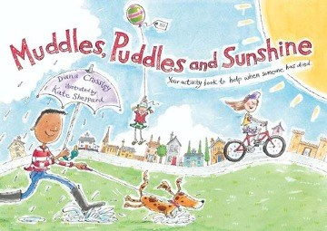
The book offers a structure and an outlet for the many difficult feelings which inevitably follow when someone dies. It aims to help children make sense of their experience by reflecting on the different aspects of their grief. At the same time, the book manages to find a balance between remembering the person who has died and having fun

Fred
Posy Simmons (Jonathan Cape, 1987, ISBN 0-2240-2448-5)
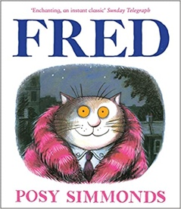
(0-5 years)
When Fred the cat dies his owners, Nick and Sophie, attend his funeral and learn about his secret life as a famous singer. The story raises the idea of celebrating a life in a good-humored and touching way, with entertaining pictures and not much text.

We Love Them
Martin Waddell (Walker Books,1990, ISBN 0-7445-7256-8)
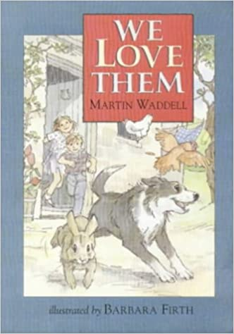
(2-6 years)
Death is seen very much as part of life in this nicely illustrated story of life in the country, which conveys the idea that life goes on and that old creatures give way to young ones.

I'll Always Love You
H Wilhelm (Hodder & Stoughton, 1985)
(3-7 years)
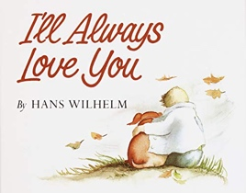
A touching story of the love between a little boy and his dog, who have grown up together. When the dog dies, the boy says that, although he is very sad, it helps that he used to tell the dog "I'll always love you" every night. An opportunity to discuss the importance of telling people or animals how you feel.

Liplap’s Wish
Jonathan London and Sylvia Long (Chronicle Books, 1994, ISBN 0-8118-0505-0)
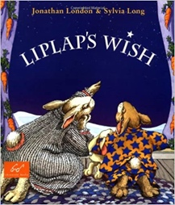
(3-8 years)
Liplap the rabbit's grandma has died, and his mother tells him of the rabbit legend that "long ago, when the first rabbits died, they became stars in the sky. And to this day, they come out at night and watch over us. And they remind us that our loved ones shine forever in our hearts.

Remembering Grandad
Sheila and Kate Isherwood (Oxford, ISBN 0-19-272368-5)
(4+ years)
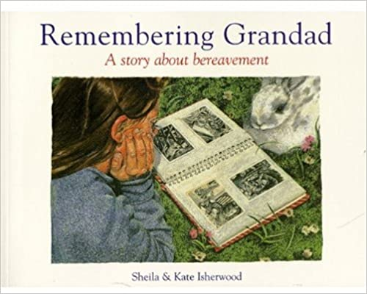
A girl's grandfather has died and looking back over the happy times they enjoyed together helps her to cope with the loss. Very specific episodes and illustrations give it a life-like feel and it could help children to think about how to remember someone.

Water bugs and Dragonflies – Explaining Death to Young Children
Doris Stickney (Pilgrim Press, 2009, ISBN 978-0829818307)
(4-8 years)
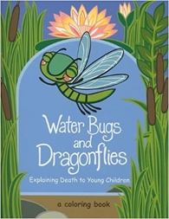
Water Bugs and Dragonflies tells the story of a small colony of water bugs living happily below the surface of a quiet pond. Every so often one of them climbs up a lily stalk and disappears from sight, never to return. Those left behind are faced with the mystery of figuring out what has become of them.

Grandma’s Bill
Martin Waddell (Macdonald Young Books, pb, ISBN 0- 7500-0307-3)
(4-8 years)
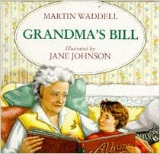
Bill's grandma is a widow, and he learns about her "other Bill" by looking through her photo album with her. Covers themes of death and living on through family memories in quite a typical middle class setting.

When Dinosaurs Die
L & M Brown (Little, Brown, 1996, hb, ISBN 0-316-10197-7)
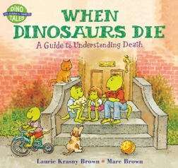
(4-8 years)
Charming busy anthropomorphic pictures of dinosaurs illustrate topics and questions and a range of answers about death: Saying Goodbye; Customs and beliefs about death; Why do people die? What does "dead" mean? It is also quite acute psychologically, acknowledging that disbelief, anger, fear, and sadness are common feelings when someone dies.

The Day the Sea Went Out and Never Came Back
Margot Sunderland (Routledge ISBN-13 ‎978-0863884634)
(4-12 years)
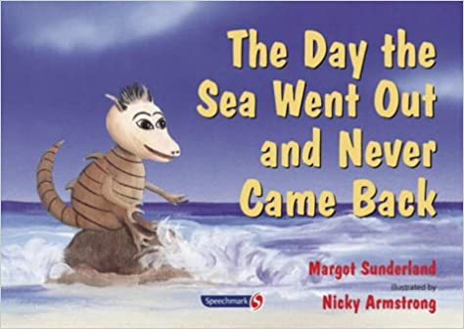
This is a story for children who have lost someone they love. It tells the story of Eric the sand dragon who loves the sea and watches it go out and come back every day. One day the sea does not come, back and he feels like he has lost everything. After much sadness, Eric finds a dying wildflower and saves it with some water. He then grows a whole rock pool garden full of flowers and finds the courage to feel the full pain of his loss and treasure his memories of the sea he loved so much.
A Nifflenoo Called Nevermind: A Story for Children Who Bottle Up Their Feelings
Margot Sunderland (Routledge ISBN-13 978-0863884962)
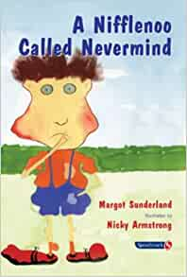
(5-6 years)
This is story for children who bottle up their feelings. Nevermind always carries on whatever happens. Each time something horrible happens to him he just tucks his feelings away and carries on with life. Eventually, Nevermind begins to understand that his feelings do matter, and he learns to express them and stand up for himself.

Granpa
John Burningham (Puffin, 1998, ISBN 0099-43408-3)
(5-7 years)
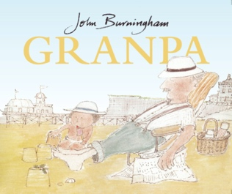
Designed to stimulate discussion rather than to tell a story, the book has a series of scenes of a little girl and her grandad, with comments from each or both of them. At the end, she is shown staring at his empty chair, without comments. The book allows the adult to direct discussion about not only the good things that the child remembers, but also the not so happy memories.

Grandad, I'll Always Remember You
De Bode and Broere (Evans / Helping Hands, 1997, ISBN 0237-51755-8)
(5-7 years)
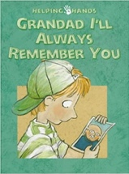
A picture book about loss and memories, and potentially a good stimulus to talk about a bereavement.

Lifetimes: The Beautiful Way to Explain Death to Children
Bryan Mellonie and Robert Ingpen (Belitha Press, 1997, ISBN 1-85561-760-9)
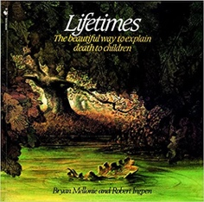
(5-8 years)
This book places human life and death firmly in the natural world, and the tone is quietly reflective: "All around us everywhere, beginnings and endings are going on all the time. It may be sad, but it is the way of all things. For plants. For people. For birds”. This book is truthful and puts death in perspective.

The Huge Bag of Worries
Virginia Ironside (Hodder Children’s Books, ISBN-13 ‏ 978-0340903179)
(5-9 years)
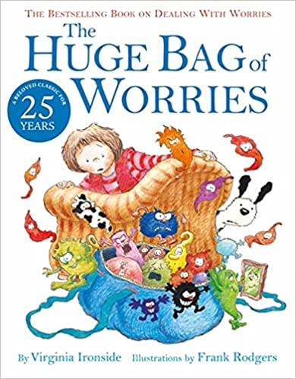
Wherever Jenny goes, her worries follow her – in a big blue bag. They are with her all the time, at school, at home, when she is watching TV and even in the bathroom! Jenny decides they must go, but who will help her get rid of them? A funny and reassuring look at dealing with worries and anxiety, to be used as a springboard into important conversations.

Badger’s Parting Gifts
Susan Varley (Collins Picture Lions, pb, 1992)
(6-9 years)
A charming, illustrated book in which a very old and much-loved badger dies. The forest animals gather and reminisce about the important part Badger played in their lives, and as time passes memories of Badger make them smile. These memories were different for each of them, including very recognisable things like a favourite recipe or showing someone how to knot a tie - Badger's "parting gifts. Child Bereavement UK have an information resource for this book: https://www.childbereavementuk.org/Handlers/Download.ashx?IDMF=a1f7111c-3023-4107-95ba-4d39938c6465

I Feel Sad
Brian Moses & Mike Gordon (Wayland, ISBN 0-7052-1406-6)
(6-11 years)
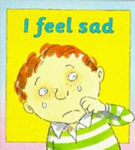
Not specifically about death, but about different ways of expressing sadness. Could be a useful opening for a conversation about a bereavement, or about coping with feelings.

Sad Book
Michael Rosen (Walker Books, ISBN 13: 9781406317848)
(7+ years but Rosen notes suitable for everyone)
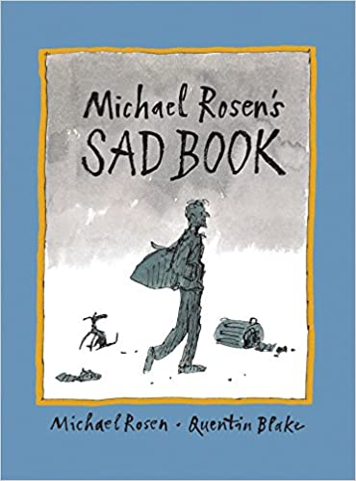

Michael Rosen talks about his sadness after the death of his son. A simple, personal story that speaks to everyone, adult or young person.

Us Minus Mum
Heather Butler (Little Brown Books for Young Readers ISBN 9780349124070)
(7-12 years)
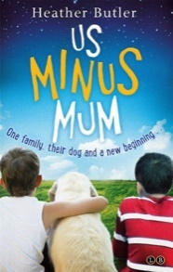
The boys think Mum is invincible. But they’re wrong. Because Mum is ill. Really ill. It’s up to George and Theo to keep Mum (and everyone else) smiling – which will almost probably definitely involve willies, shepherd’s pie and Goffo’s victory at the pet talent show. This book is both funny and sad.

A Birthday Present for Daniel
Juliet Rothman (Prometheus Books, ISBN 1-57392-054-1)
(8-12 years)
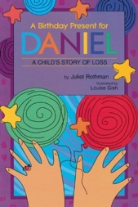
Ellen has lost her brother, and she shares with readers just how his death has changed the way her family interacts and the way she thinks about herself and others. This sensitive book is designed to generate discussion between children and adults as each page provides opportunities for communication, understanding, expression of feelings, and support from the little girl's parents.

Books on Bereavement – Secondary age

What on Earth Do You Do When Someone Dies?
Trevor Romain (Free Spirit Publishing (ISBN: 9781575420554)
(8-14 years)
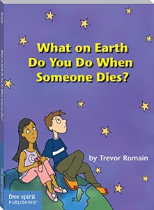
Written by Trevor Romain after his father died, this book suggests ways of coping with grief and offers answers to questions such as ‘Why do people have to die?’ and ‘How can I say goodbye?’ Friendly, accessible text and illustrations.

Sometimes Life Sucks: When Someone You Love Dies
Molly Carlile (Allen & Unwin, ISBN: 9781742371887)
(12+ years)

Teenagers can experience death in all kinds of ways. Full of tips and stories, this will help them to make some sense of their shock and grief.

The Grieving Teen
Helen Fitzgerald (Simon & Schuster Ltd, ISBN 978-0684868042)
(13-17 years)
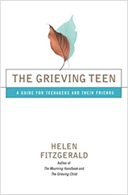

Written about, but also for teenagers, this book covers the entire range of situations in which grieving teens and their friends may find themselves. It offers explanations and guidance in a very accessible format.

The Fault In Our Stars (also a film)
John Green (Penguin, ISBN-13:‎ 978-0141355078)
(13+ years)
The story follows the main character, Hazel Grace Lancaster, as she battles cancer. Not only is Hazel trying to live the normal life of a 16-year-old girl, but she is also struggling with what it will be like for her parents after she dies.

A Monster Calls (also a film)
Patrick Ness (Walker Books, ISBN 13: 978-1406339345)
(13+ years)
Connor’s mum has cancer and life is irrevocably, disturbingly changing. First there is the nightmare, filled with screaming and falling; then there is school, where people avoid him (not knowing what to say), or persecute him.

The Year of the Rat
Clare Furniss (Simon & Schuster Children's UK, ISBN-13, 9781471120282)
(14-18 years)
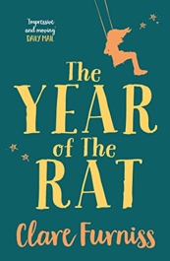
Grappling with grief is hard enough without repeat visits from the deceased. Pearl deals with death, life, and family in this haunting, humorous, and poignant debut. The world can tip at any moment, a fact that fifteen-year-old Pearl is all too aware of when her mum dies after giving birth to her baby sister

Further Recommended Reading for Teenagers from Child Bereavement UK:
https://www.childbereavementuk.org/Handlers/Download.ashx?IDMF=db5dae32-469b-4087-8220-08f015aa7a34

Further Recommended Reading for Children and Teenagers from Barnardo’s
https://www.educators-barnardos.org.uk/themes/bereavement/books-to-help-children-and-teenagers-going-through-bereavement
Social Stories
Social stories that can be adapted for children with social communication difficulties and ASD:

Lion King Themed Social Story
This example uses Mufasa’s death from the Lion King to link in the idea that others watch over us when they have died
https://www.pathfindersforautism.org/docs/social-story-about-death.pdf

Loss of a Family Member Adaptable Social Story Twinkl Resource
Story from Twinkl (subscription needed) which can be adapted to the child when they lose a family member
https://www.twinkl.co.uk/resource/t-s-3686-loss-of-a-family-member-social-stories

Autism Little Learners Someone I Love Died Social Story
Social story outlining when people die, what might happen and how we might feel.

https://drive.google.com/file/d/19jv-IkS5JcqEZpMMuvWXXP_q_VOoXFXQ/view

Example Social Story Resource
(credit to Barb Fogarty - https://elunanetwork.org/resources/supporting-grieving-children-with-autism-spectrum-disorder)

